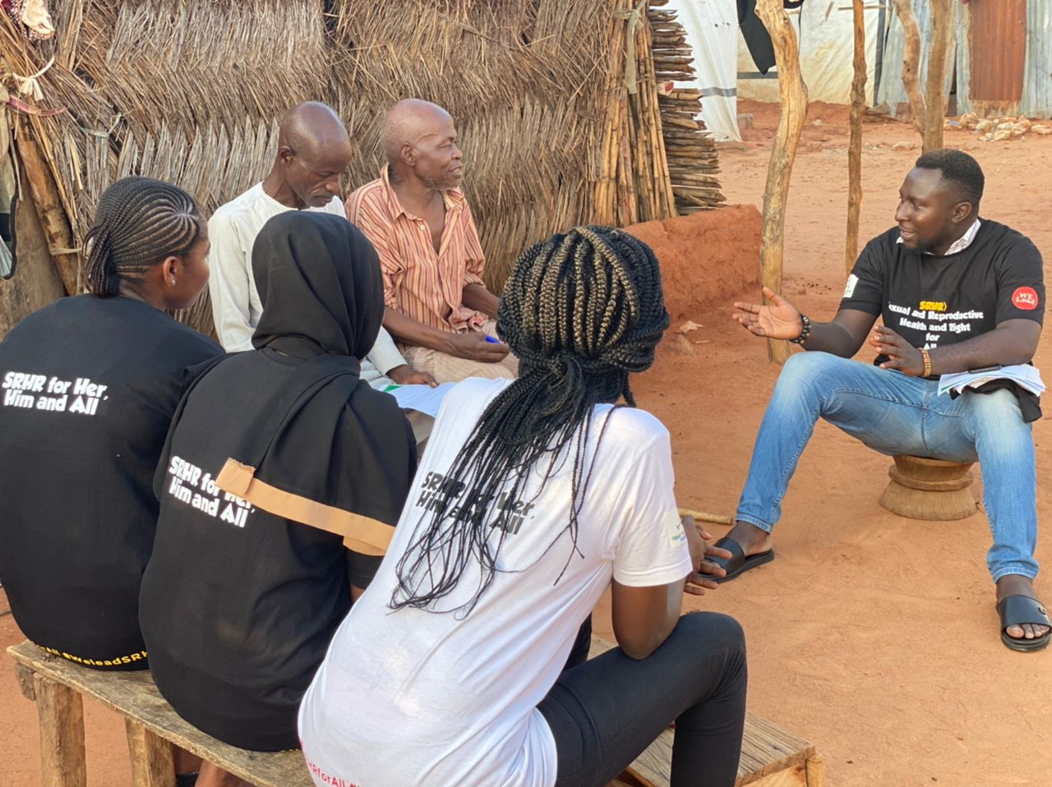

TODAY FOR TOMORROW
FOUNDATION (TFTF)

2022
ANNUAL REPORT

TABLE OF CONTENTS
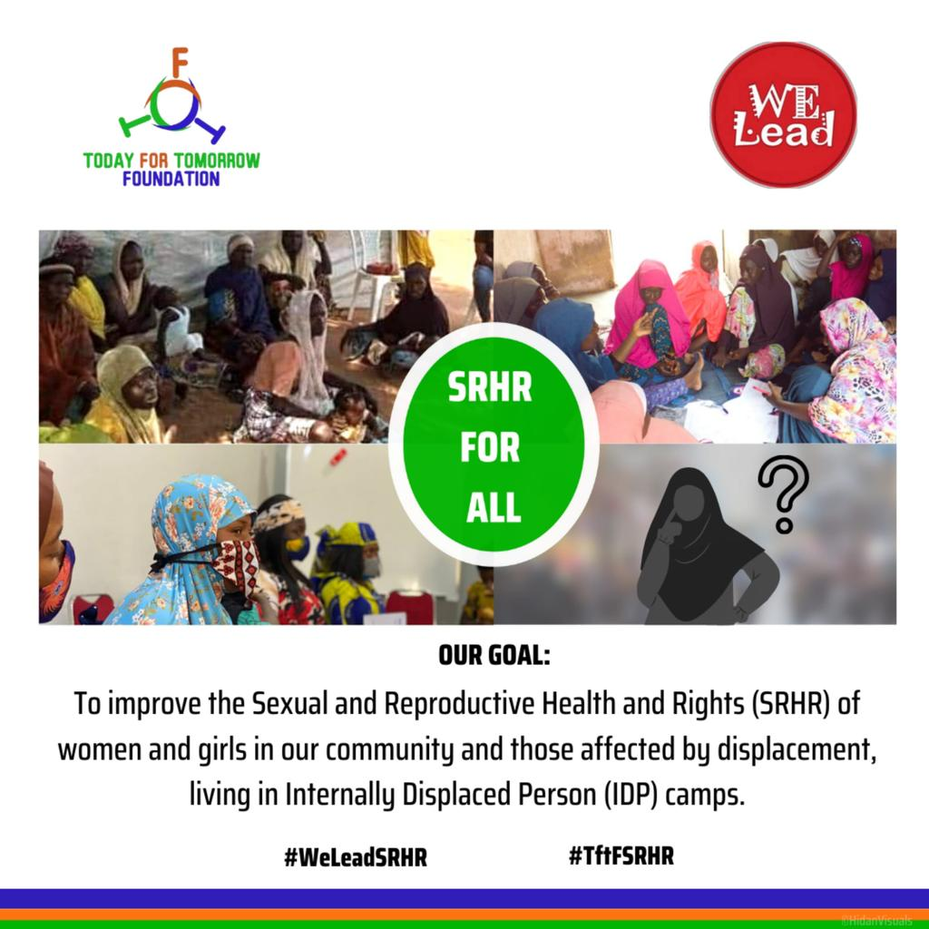
Who We Are
Today for Tomorrow Foundation (TFTF) is a youth-led, a youth-serving non-governmental organization (NGO) working with young people for young people and saddled with the responsibility of developing and implementing solutions aimed at addressing health, social, developmental and economical problems that affect the complete well-being, attainment of rights, and full potential of 10–19 years old (adolescents), 20–29 years old (younger adults), and 30-35 years old (late youth) within people affected by displacement, people living with HIV/AIDs, people living with disabilities and adolescent and youth single mums in the community.

Visit our website today, to learn more about us and our work
www.tftfoundation.org.ng

- IMPACT
- PROGRAMS
- International Commemorative Days
- HIVOS – Welead project
- North East Connection Project
- GBV Youth Drivers Project
- Partners and Donors
- Contact Information

IMPACTS
TFTF meaningfully engaged adolescents and young persons in its programming to create awareness on its thematic areas (Sexual and Reproductive Health and Rights-SRHR, Gender Based Violence-GBV, Peace Building and Economic Empowerment), equipped and conducted capacity building activities. Our organization also leveraged on transformative media approach (mass media, using radio stations and social media utilizing platforms such as facebook, twitter, linkedin and instagram) to drive campaigns.

INTERNATIONAL
COMMEMORATIVE
DAYS

World Menstrual Health and Hygiene Day, 2022
We conducted 29 days online sensitization with key messages titled “Menses is not a Mess” to debunk and deconstruct notions on existing myths and misconceptions on menstruation. Moreover, on the 29th of May, 2022, TFTF conducted a one-day physical sensitization on menstruation for boys and men in Damare Internally Displaced Persons (IDP) camp and female students of Government Day Secondary School (GDSS), Karewa, Yola, respectively, reaching a total of 66 persons.
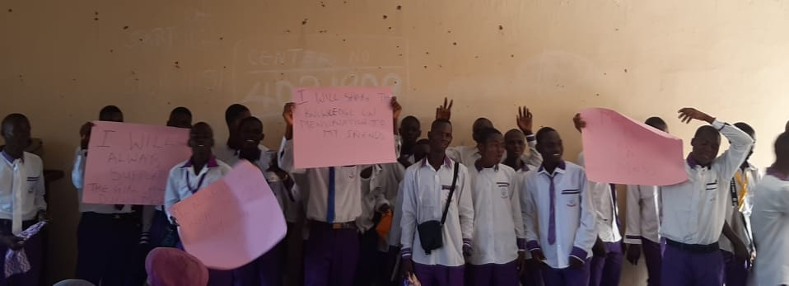
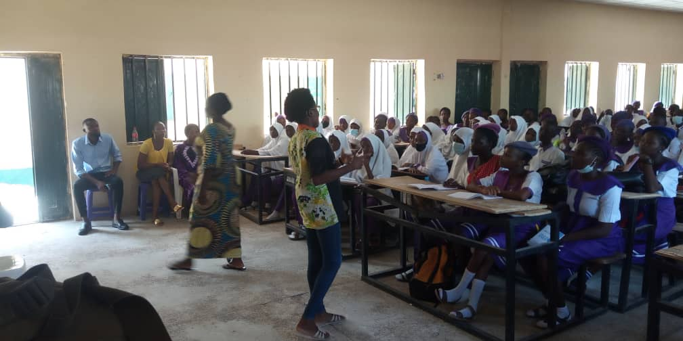
HIVOS- WELEAD PROJECT ON SRHR
Welead is an innovative and far-reaching program that aims to strengthen the influence and position of young women whose SRH-R are neglected the most. TFT is one of the community of action (COA) implementing the Welead project in the north-eastern part of Nigeria (Adamawa State). Moreso, our target group/beneficiaries are women and girls affected by displacement aged 15-45 years. However, our organization also ensure inclusivity of other vulnerable group including persons with disability.

ADVOCACY VISITS
TFTF conducted 10 advocacy visits to 5 mapped and 3 unmapped stakeholders including 1 network of women led organization, 3 line ministries (ministry of health, ministry of women affairs, Adamawa state emergency management agency), 1 youth-led civil society organization (CSO), 1 district head (Girei Local Government Area), advocacy to wife of the Lamido (traditional leader of the state), Damare and Salama Housing Estate IDP camp leaders and visit to Royalty Women for Peace and Development Initiative (ROWPEDI-a group of royal elites in the State) respectively to gain entrance, buy-in/support, collaborative partnership and alien with duty-bearers who have the political power to influence charge regarding policies and legislation on SRH-R.

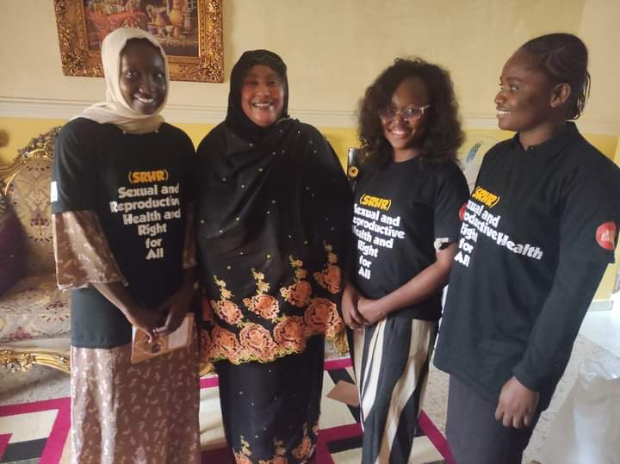
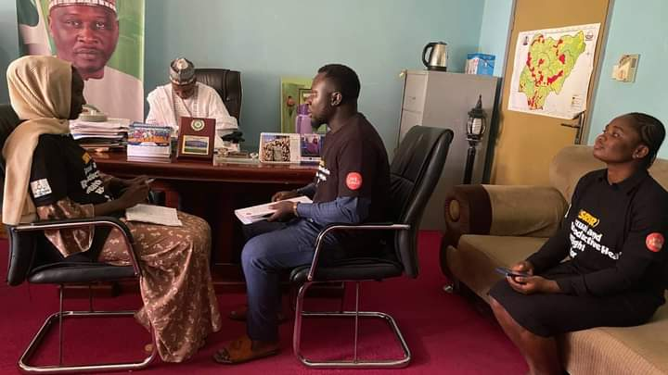

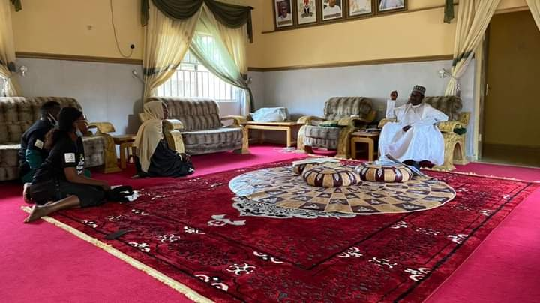
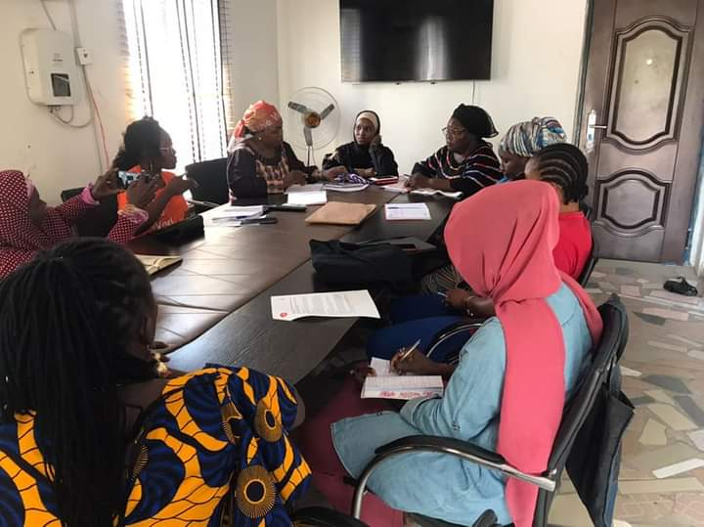
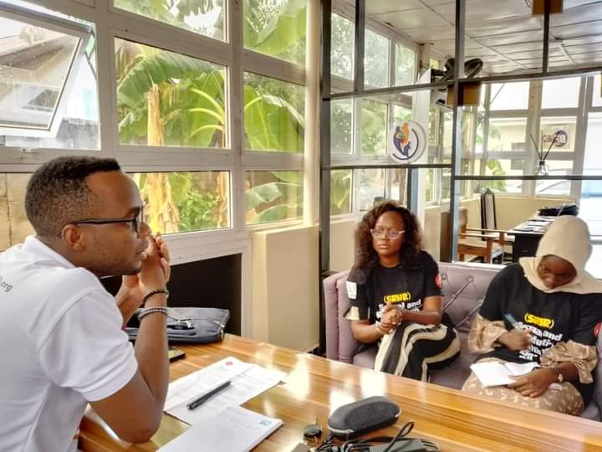

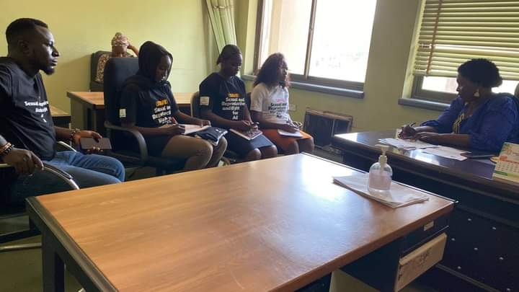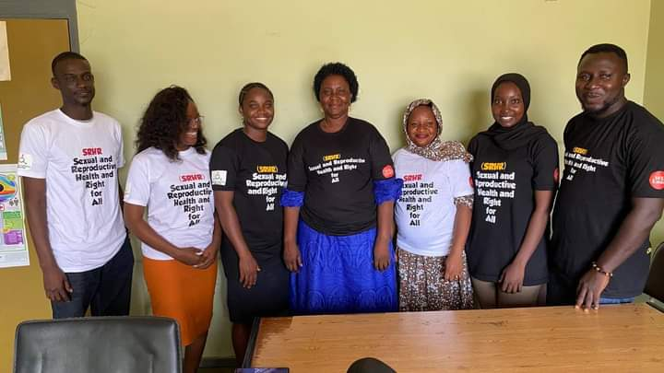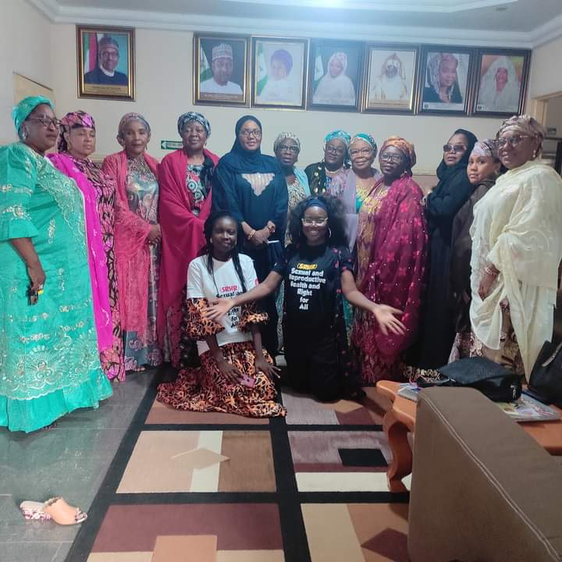

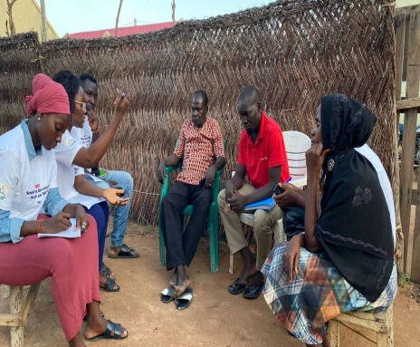
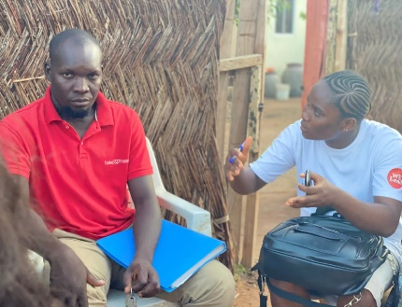

TWO DAYS TRAINING ON ADVOCACY AND STRATEGIC COMMUNICATION FOR RIGHT HOLDERS IN IDP CAMPS
TFTF trained 120 young women and girls affected by displacement aged 15-35 on advocacy and strategic communication at Damare and Salama Housing Estate IDP camps respectively. The training equipped the right holders with baseline knowledge on advocacy and strategic communication by seasoned consultants and each participant was presented with a manual on the subject matter. The girls trained took some bold steps in stepping down knowledge gained to their peers which resulted in joint advocacy to their camp leaders and health service providers at the primary health care centres in the camp settlement for provision of inclusive SRH-R services. Moreso, the sustainability of these joint efforts lies in the consistent peer -to-peer sessions held by the young women and girls at their respective camp locations.
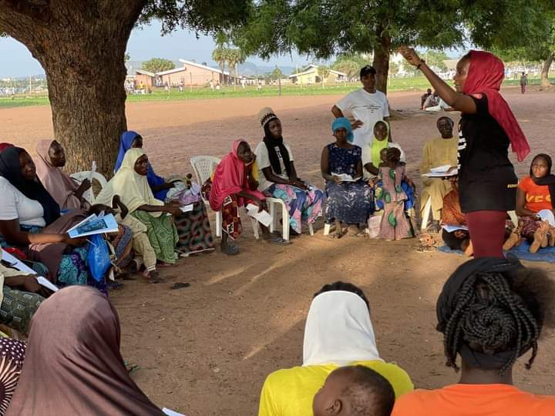
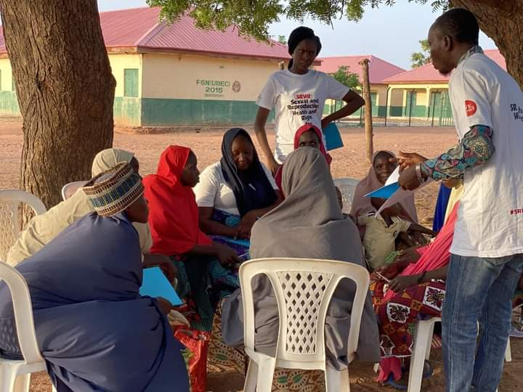
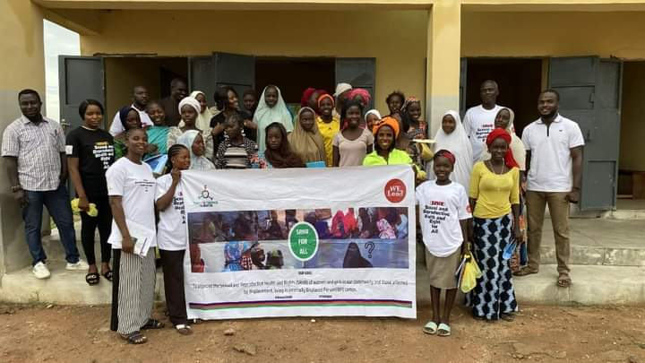
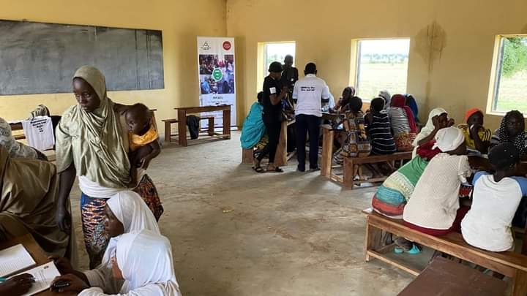

VIRTUAL SESSIONS ON SOCIAL MEDIA
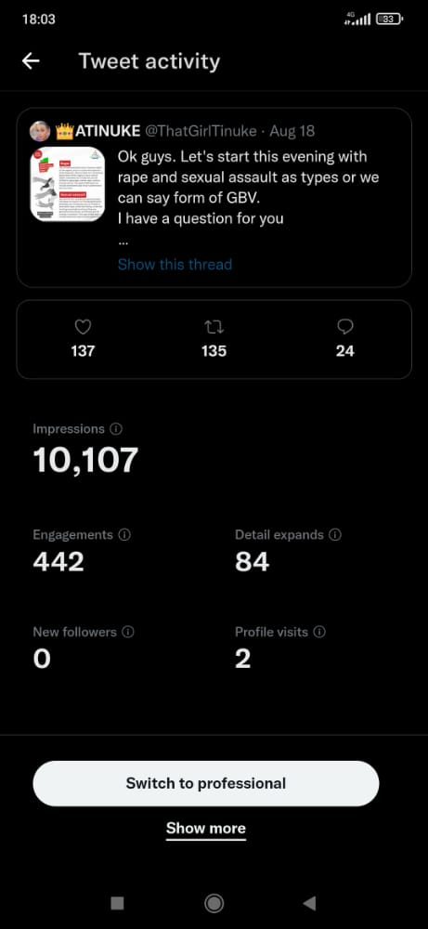
TFTF conducted two (2) virtual sessions (TFT twitter space) on intimate partner violence and marital rape respectively on 1/12/2022 which lasted for one hour (1hr) each. The session was a no judgment zone which encouraged meaningful conversations aimed at increasing knowledge on sexual rights and intimate partner violence. However, a qualitative analysis of the subject of discussion as commented by some participants puts forth an action call for joint collaborative efforts and actions in SRHR education by stakeholders and duty-bearers and advocacy engagements to redress SRH-R issues in the Nigerian law system, constitution and promulgate policies on SRH-R for all.

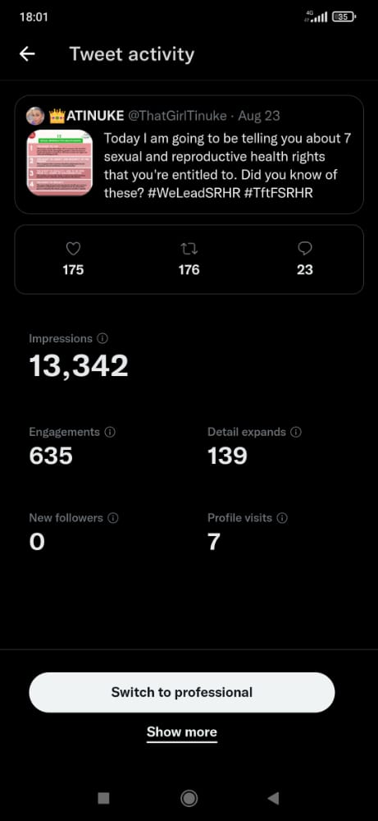
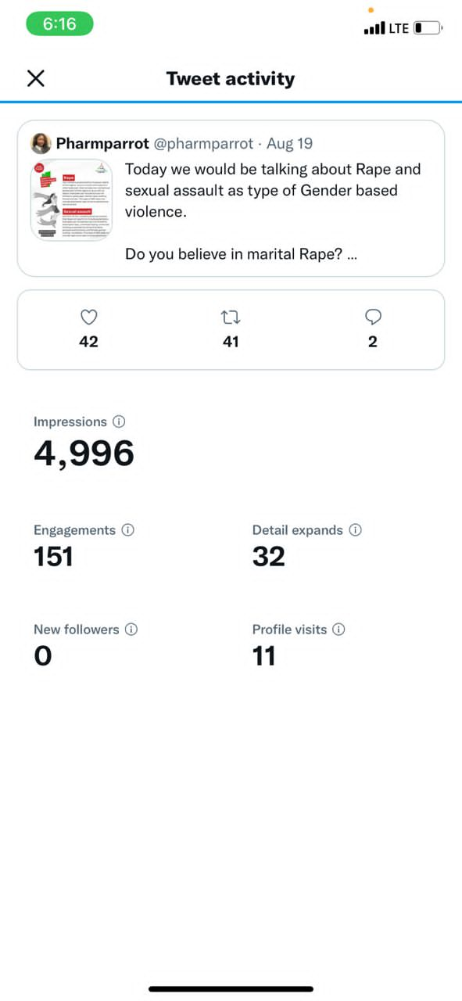

RADIO TALK SHOW ON SEXUAL AND REPRODUCTIVE HEALTH RIGHTS

TFTF organized a three days radio talk show programme on SRH-R at NAS FM (89.9), Yola with five (5) TFTF team members in attendance (including 4 females and 1 male). The talk show was aimed at educating and accelerating public consciousness on SRHR, including access to services and existing needs and gaps. During the program, it was deduced that listeners have limited knowledge on SRH-R and callers/listeners attested that the myths around SRHR stemmed from cultural norms and belief systems and as such craved for more awareness and sensitization on SRHR and its components so as to enable them realize their reproductive rights.

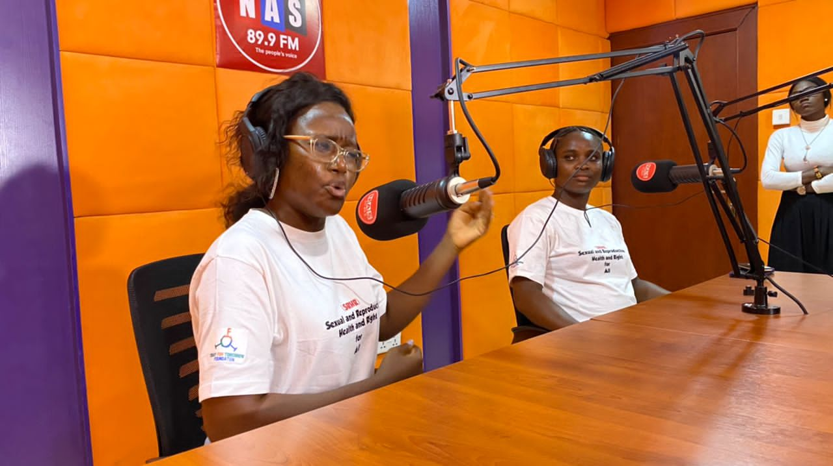

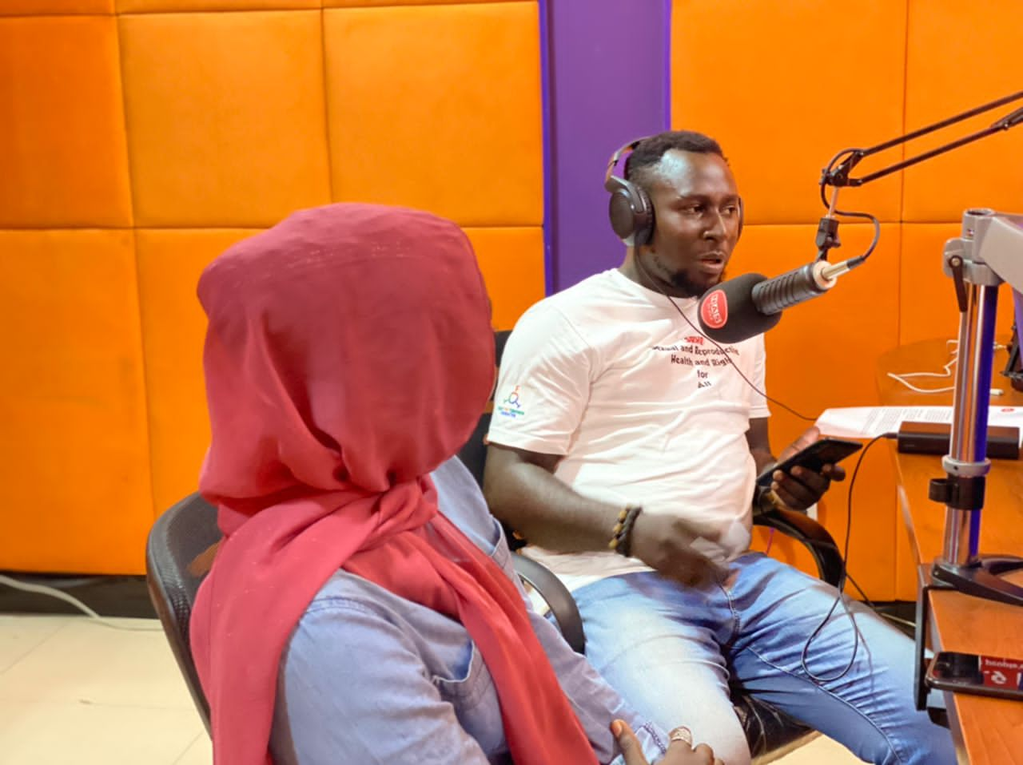
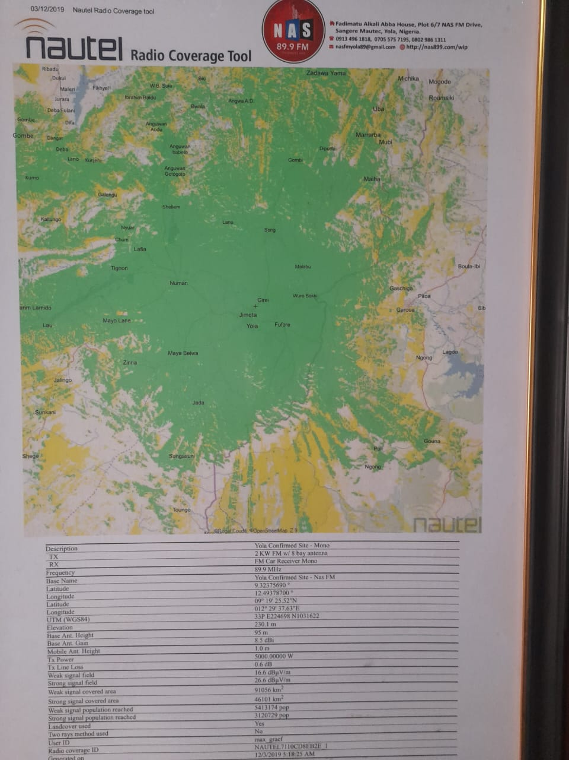

STRENGTHENING THE SAFE SPACES IN IDP CAMPS WITH SRH MATERIALS AND RELATED COMMODITIES

Prior to the safe space strengthening, we conducted needs assessment to prioritize SRH-R needs for our target group. On 29th November, 2022, TFTF purchased and distributed some commodities including; HIV testing kits, menstrual beads cycle banner, menstrual kits, family planning pills and tablets, contraceptives, clinical gloves amongst others at Damare IDP Camp and Salama Housing Estate IDP Camp, Jabbi Lamba in Girei L.G.A, to increase availability and accessibility of these services and address unmet SRH needs at the safe spaces respectively.
Moreso, these commodities were presented to the camps leaders, women leaders and community health workers in the respective IDP Camps and the leaders were implored on the modalities for disbursement of SRH materials/commodities without any form of discrimination to the women and girls in the IDP camp.
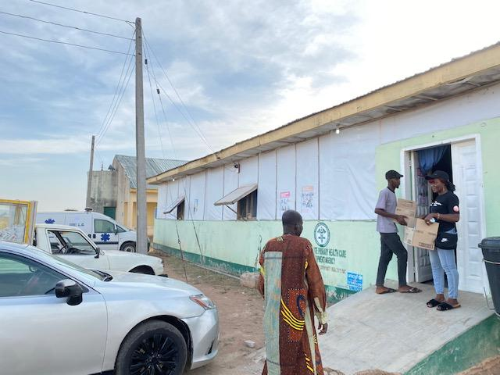

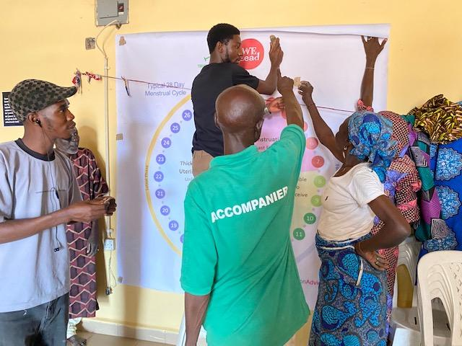
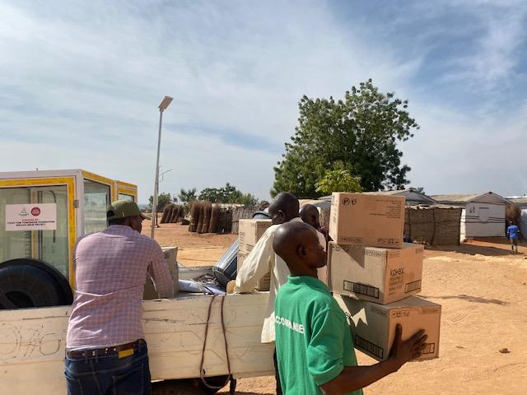
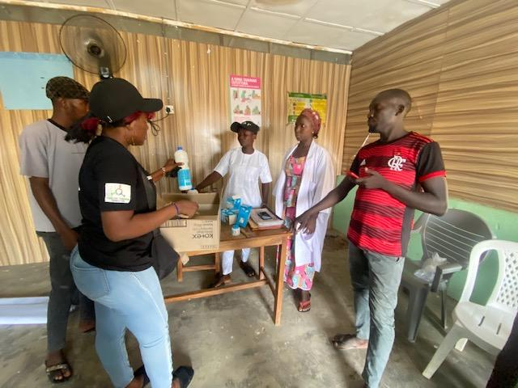
SRHR INTEGRATION CONVERSATION FOR EXECUTIVE DIRECTORS AND PROGRAMME MANAGERS

TFTF organized a one-day SRHR integration conversation for Executive Directors and Programme Managers in Adamawa State on 11/12/2022 at Homtel Hotel, Barracks Road, Yola L.G.A. with thirty (30) participants in attendance. The aim of the conversation was to increase SRHR programming in the state. During the session, SRHR needs for right holders were identified, unmet needs for SRHR were identified and SRH gaps were extensively discussed. Notable contributions of the Ministry of Health in breaching the accessibility to SRHR services were also highlighted including; issue of SRHR coordination by partners in the state and limited conversations on SRHR due to cultural norms, belief systems and other identified gaps.
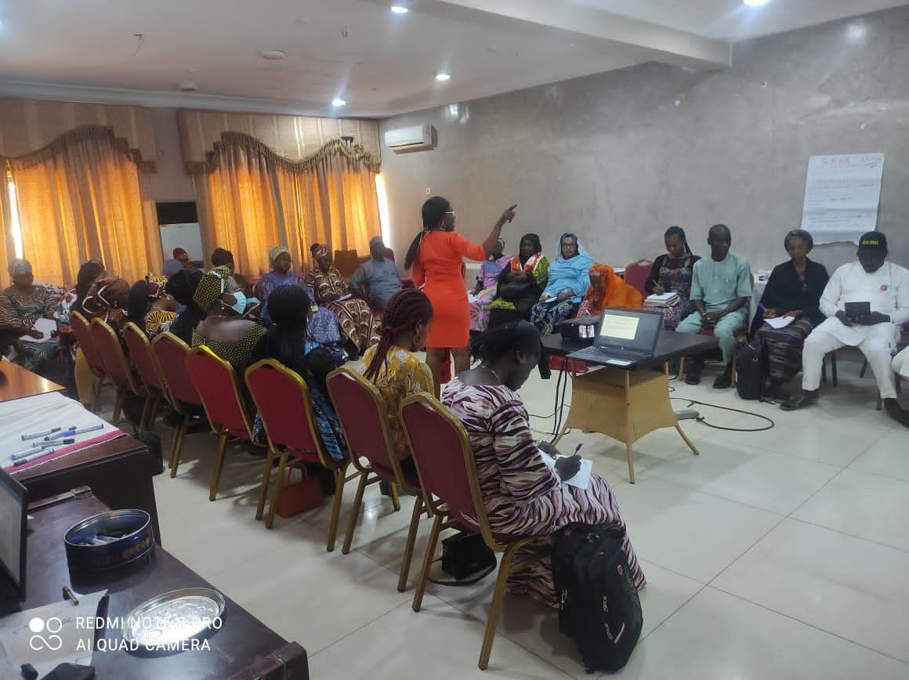
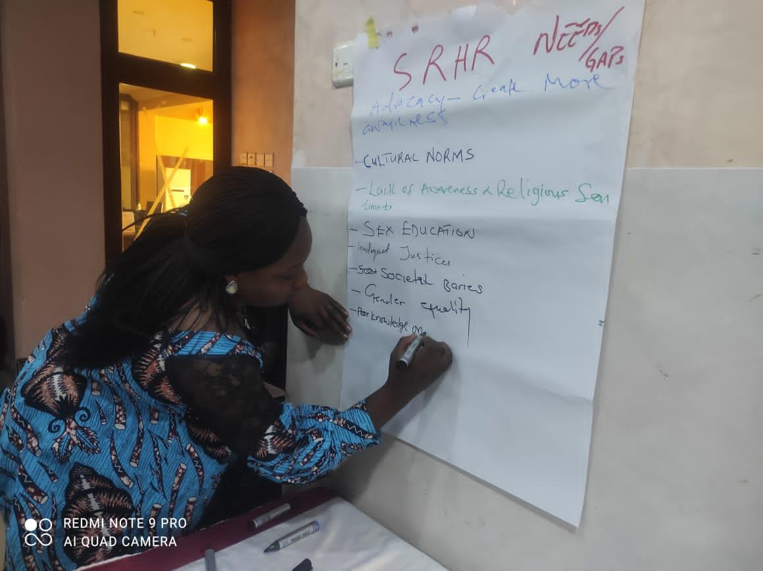
NORTHEAST CONNECTION
PROJECT

Northeast connection in partnership with American University of Nigeria (AUN), Yola mapped out 10 nascent organizations thematically implementing projects on peace building and governance. TFTF was selected to implement a capstone activity to enhance women skills and knowledge in building resilience towards conflict mitigation in Numan L.G.A through training and mentoring.

NORTHEAST CONNECTION CAPSTONE ACTIVITY, 2022

TFTF conducted a one-day training on strengthening the skills and knowledge of women in conflicts mitigation and building resilience in Numan L.G.A. for 5 women groups (each consisting of about 10 women) on 18th October, 2022 held at Mope Hotel, Numan L.G.A, Adamawa State. The training was anchored by 2 (two) seasoned experts. Representatives from the North East Connect and American University of Nigeria were also in attendance to supervise the overall conduct of the training. The training was tailored to areas such as violence and radicalization, equipping women with skills in preventing counter terrorism and empowering them to become violence antagonists. This training enabled the women group to synergize and jointly collaborate in mitigating conflicts issues within their local communities which led to a constitution of steering committee consisting of youth leaders and community leaders saddled with the responsibilities of enhancing peace-keeping in their community.
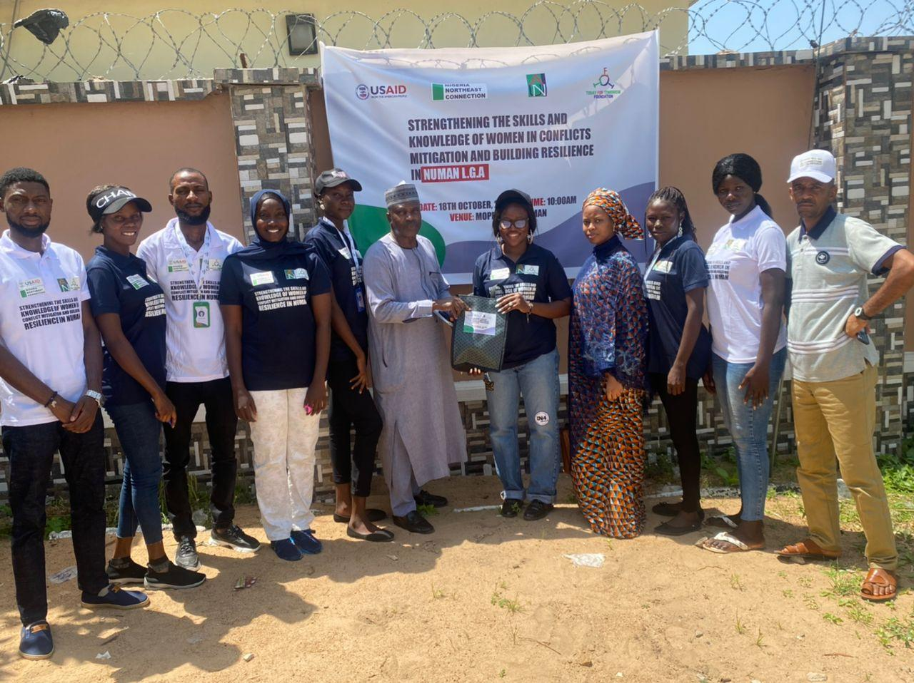
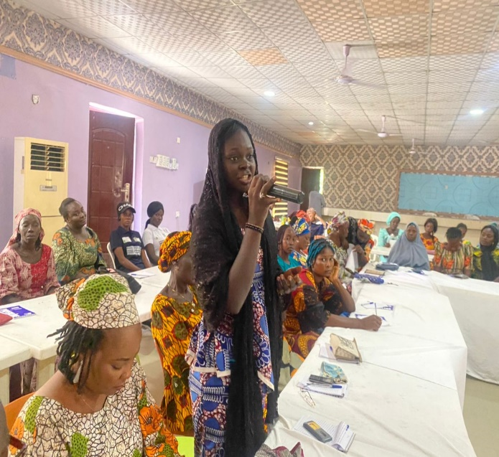
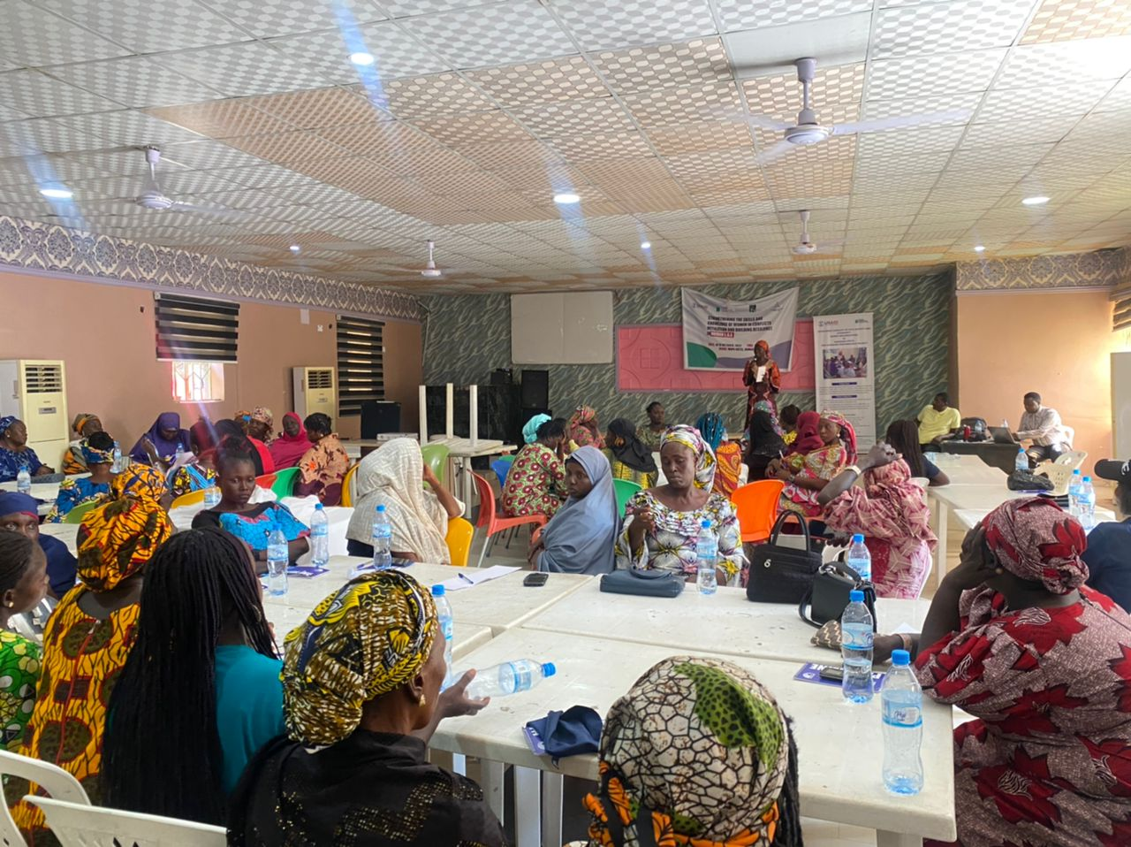

GENDER BASED VIOLENCE (GBV)
YOUTH DRIVERS PROJECT

UN women Nigeria which strengthens women in amplifying their voice and prioritizes women’s empowerment, supported TFTF with mini grant in creating awareness and sensitization on Gender Based Violence (GBV) in Adamawa State.

GBV YOUTH DRIVERS PROJECTS
We launched the GBV Youth Drivers (GBV-YD Project) implemented across four (4) L.G.As (Yola North, Yola South, Demsa and Girei), Adamawa State aimed at GBV risk mitigation in Adamawa State. Twenty (20) youth drivers were trained on GBV and undertook the GBV online course by UNFPA to gain more knowledge on GBV as well as its types and referral pathways.
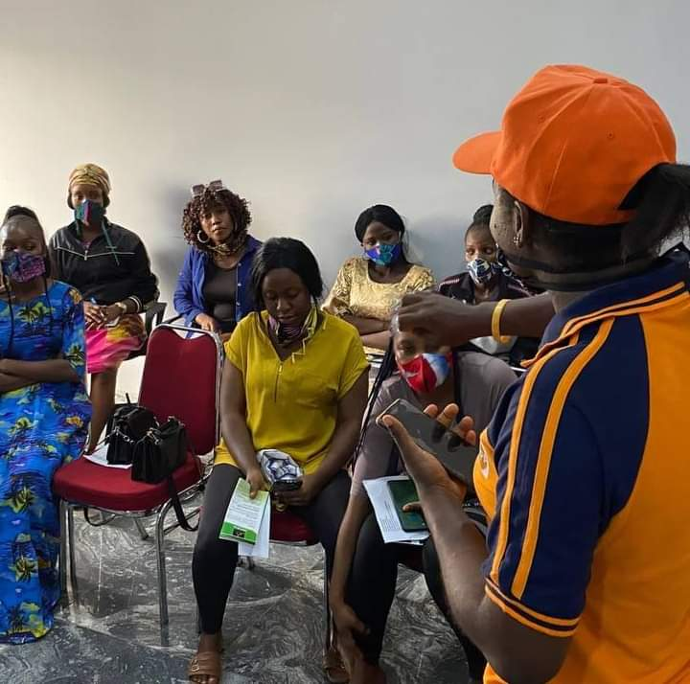

PARTNERS

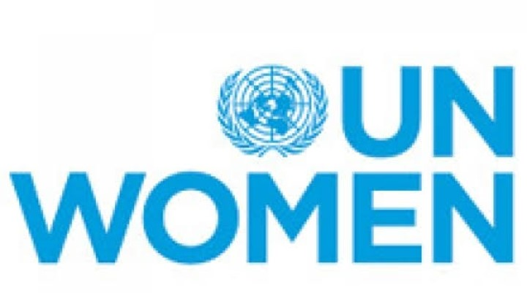
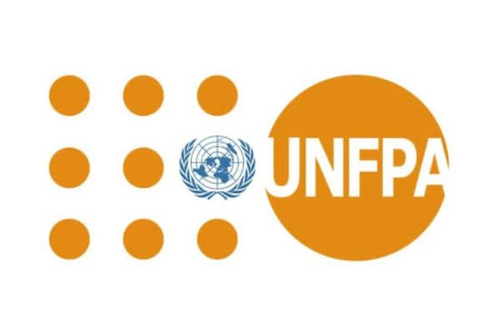
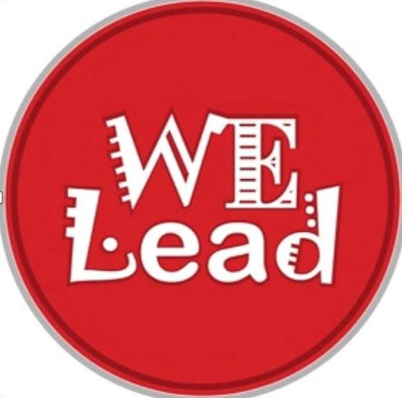

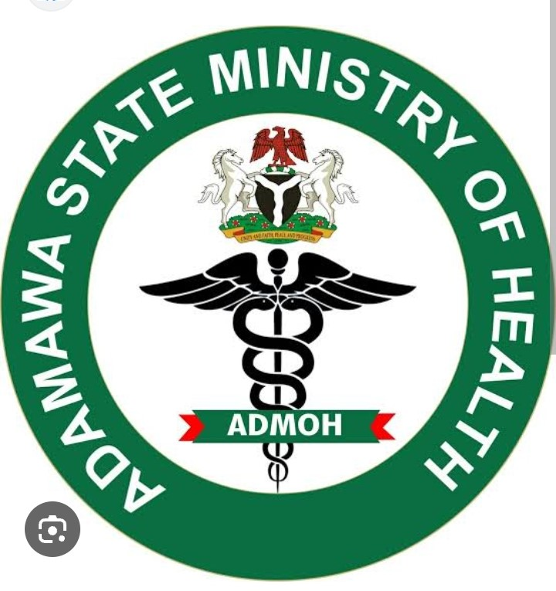
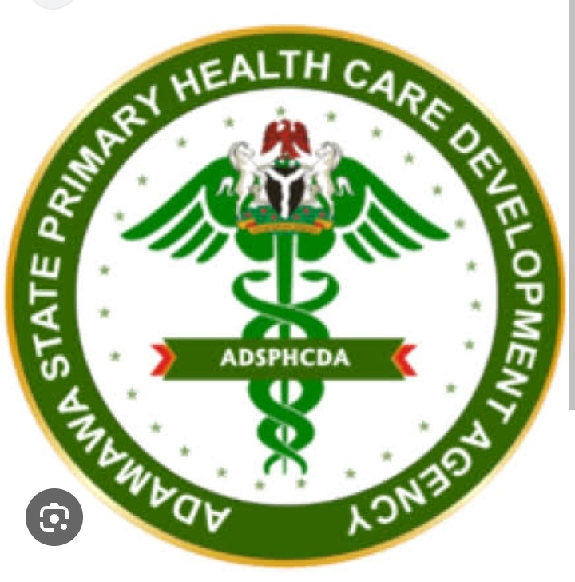

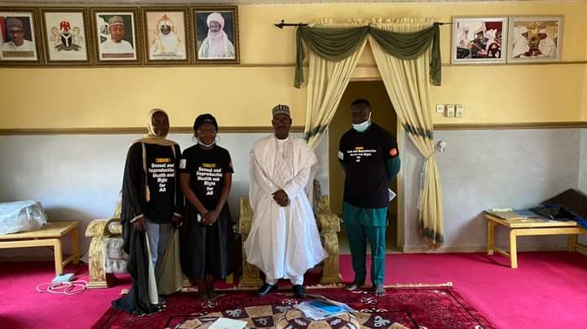




Todayfortomorrowfoundation today4tomorrowfoundation FoundationTft
Todayfortomorowfoundation

Kerawa massakare by Boys brigade, kimeta Yola.
Email: today4tomorrowfoundation@gmail.com or tftf@tftfoundation.org
Phone No: + 234 (0) 8167388820

