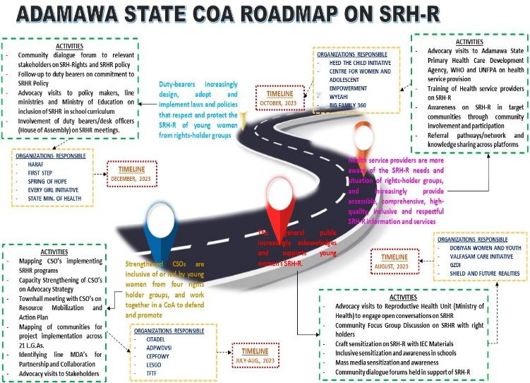

TODAY FOR TOMORROW INITIATIVE (TFT)

2023
ANNUAL REPORT

TABLE OF CONTENTS
Who We Are
Today for Tomorrow Foundation (TFTF) is a youth-led, a youth-serving non-governmental organization (NGO) working with young people for young people and saddled with the responsibility of developing and implementing solutions aimed at addressing health, social, developmental and economical problems that affect the complete well-being, attainment of rights, and full potential of 10–19 years old (adolescents), 20–29 years old (younger adults), and 30-35 years old (late youth) within people affected by displacement, people living with HIV/AIDs, people living with disabilities and adolescent and youth single mums in the community.

Visit our website today, to learn more about us and our work
www.tftfoundation.org.ng
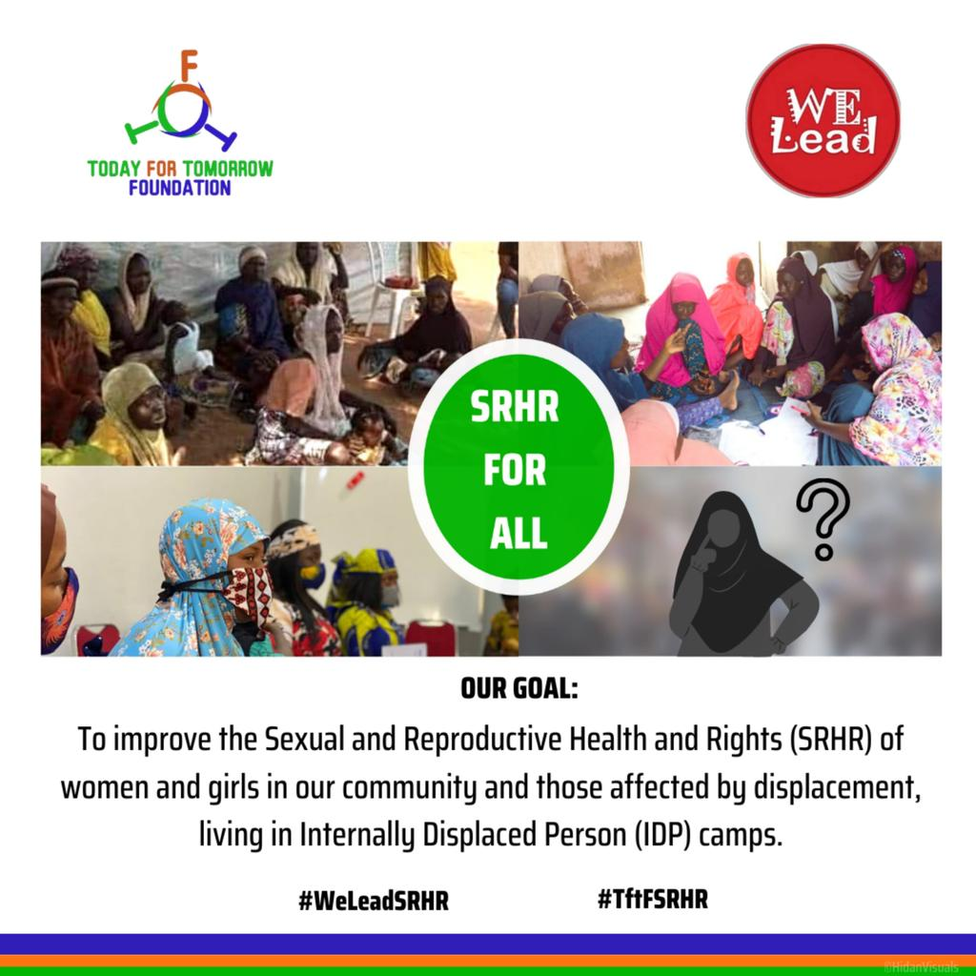

- IMPACT
- PROGRAMS
- International Commemorative Days
- HIVOS – Welead (SRH-R) Project
- Mental Health Project
- AHI Project
- Partners and Donors
- Contact Information

IMPACTS
TFT integrated intersectional approach by ensuring that persons with disability and persons affected by displacement were meaningfully engaged in all program implementations for the year. Also, reporting tools and templates were re-designed to meet standard requirements capturing persons with other gender identities. In furtherance, our organization also integrated media components which was a transformative tool in increasing public consciousness on our thematic areas including; Gender Based Violence, Mental Health and driving public conversations on SRH-R through the radio jingles and radio drama play leveraging on 2 radio stations with high frequency across the state.

223

600

7,000,194

382

International Commemorative Days

SRH-R
Welead Project

Mental Health Project

AHI Project

INTERNATIONAL
COMMEMORATIVE
DAYS

- International Adolescent Health Week, 2023
TFT commemorated International Adolescent Health Week 2023, in collaboration with UNFPA, AfriYAN and SAYPHIN aimed at sharing youth-friendly technology innovations and programs that promote access to SRH-Information and services (such as’; AskTheDoc, Frisky, Hello Lagos, Young Mum Clinic, Safe Space Hubs, HIV self-testing, etc). TFT served as a viewing center with 30 participants in attendance inclusive of adolescents and young persons with disability aged 10 -29 years, with keen interest in youth-friendly innovations.
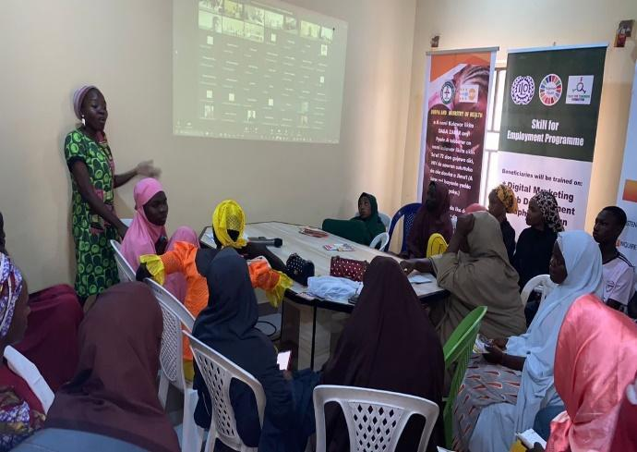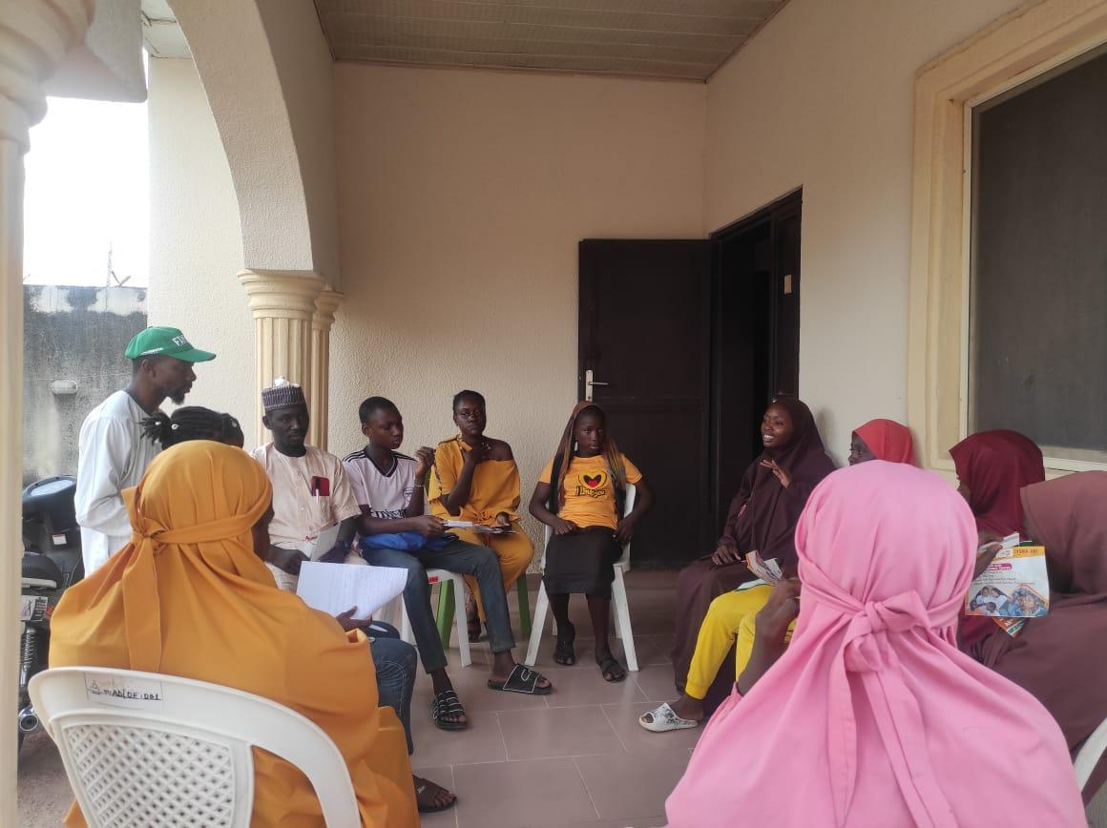
- World Menstrual Hygiene Day, 2023
TFT, in partnership with Haraf and Against all Odds Foundation, Yola, Adamawa State, commemorated the World Menstrual Hygiene Day, 2023 on 31st May, 2023 at Bekaji Secondary School, Jimeta, Yola North, with seventy-four (74) secondary school students (girls and boys) and two (2) teachers in attendance. The aim of the activity was to sensitize and educate the students about menstrual hygiene using a developed question guide and enhance open students’ conversation on menstruation. Moreso, during this activity, facilitators led the participants (students) in sharing their menstrual health journey and experiences which was engaging as every participant had the opportunity to amplify their voices and share their opinions and unique experiences of their menstrual health.
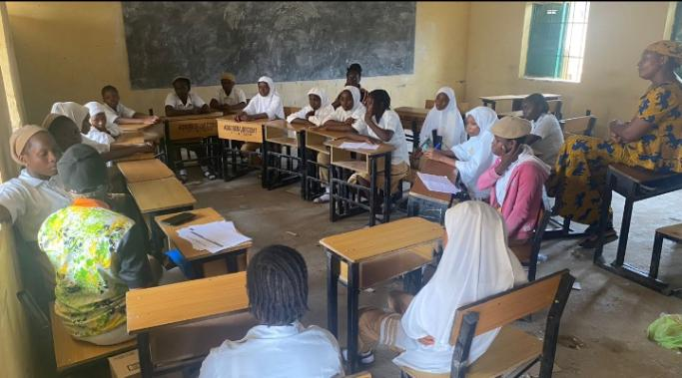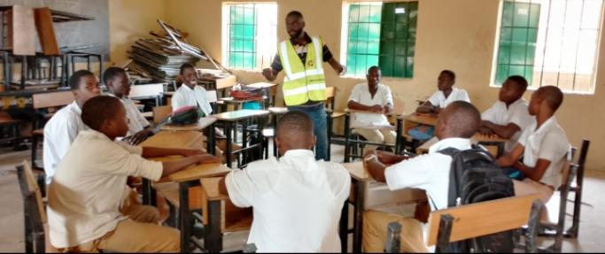
MENTAL HEALTH PROJECT
Our organization as a social enterprise collaborate with youths who are passionate about mental health and envisions a society free from mental health prejudice, stigma and discrimination. This joint effort has led to wellness sensitizations and campaign, trainings and research striving to build a society where people have a good and healthy relationship and maximize their potentials through mental health information and care.

Mental Health Awareness Campaign, 2023
TFT created educative media contents on mental health to provide in-depth analysis of mental health needs, issues and gaps which affects adolescents and young persons leveraging on social media platforms which is the most utilized platform by target audience. Moreso, our organization organized a facebook live session on mental health awareness held on 21st May, 2023 with two hundred and twenty-three (223) participantsin attendance. Four guest speakers made some presentations and enlightenment talk on Mental Health and areas discussed were as follows: meaning of mental health, self-care tips, importance of seeking help and referral pathways on mental health were extensively discussed with reflection moments and experience sharing by one of the speakers who had bipolar disorder.
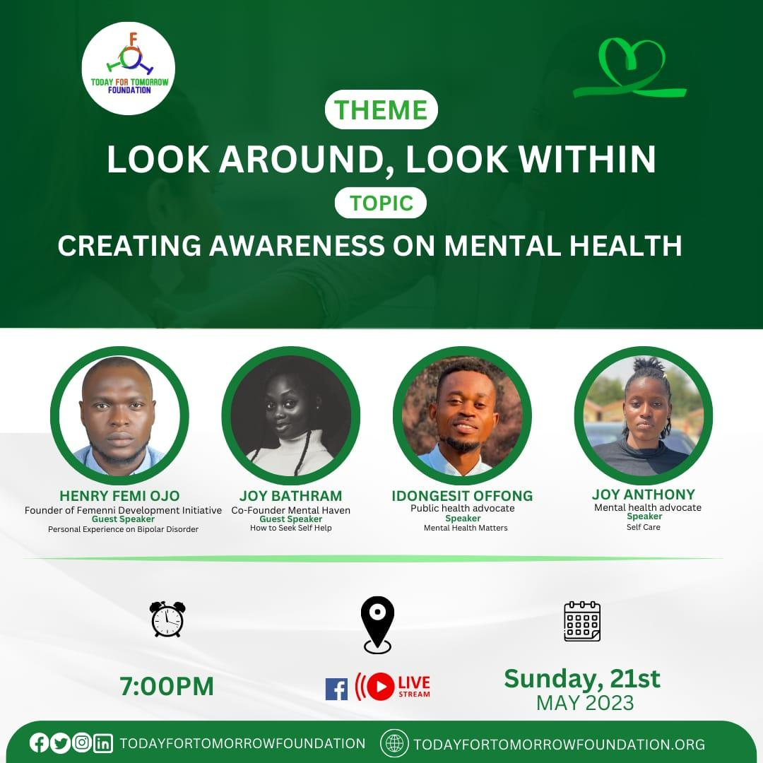

HIVOS- WELEAD PROJECT ON SRHR
Welead is an innovative and far-reaching program that aims to strengthen the influence and position of young women whose SRH-R are neglected the most. TFT is one of the community of action (COA) implementing the 3rd phase of welead project on Sexual and Reproductive Health and Rights (SRH-R) in the north-eastern part of Nigeria (Adamawa State). Moreso, our target group/beneficiaries are women and girls affected by displacement aged 15-45 years. However, our organization also ensure inclusivity of other vulnerable group including persons with disability.

ADVOCACY VISIT TO THE DIRECTOR OF PUBLIC HEALTH
TFT conducted an advocacy visit to the Director of Public health to prioritize the access and utilization rate of SRH services and commodities amongst women and girls affected by displacement in Adamawa State. During the visit, a fact sheet containing the progress, challenges, interventions of the Welead project and our ASK was presented. This led the director of public health affirm his support to the organization in SRH programme implementation activities and served as a referral linkage to the desk officer for humanitarian activities (who often receive SRH-R commodities from national and international partners) for the organization to gain access to reproductive health commodities from the ministry of health. Also, the public health director committed to collaborating and synergizing with TFT, all partner organizations working on the same thematic area and as well, knowing their areas of prioritization (risk mitigation, service provision or case management).

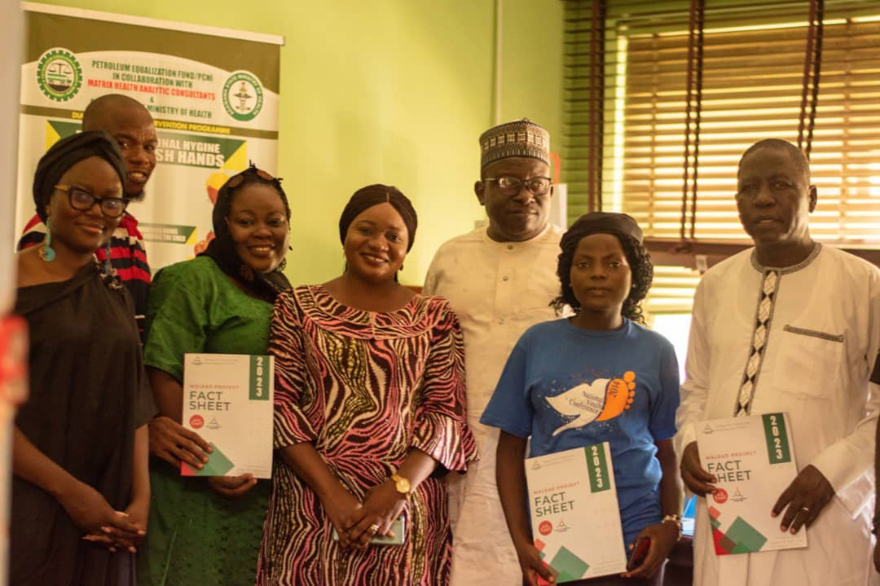
ADVOCACY VISIT TO THE COMMISSIONER OF WOMEN AFFAIRS
TFT conducted an advocacy visit to the commissioner of women affairs to gain her support in advocating for access to youth-friendly SHR-R information and services for women and girls in Adamawa State. During the visit, a fact sheet containing the progress, challenges, interventions of the Welead project and our ASK was presented. The Commissioner of Women Affairs committed to partnering and collaborating with the organization to identify and support SRH-R issues and needs respectively, in the state. She also added that her office will support in synchronizing allocation of budget for SRH-R activities. Moreso, she committed to aligning with other line ministries (such as Ministry of Health, Ministry of LGAs and PHCs) to plan and establish technical and steering committees that will create linkages for safe space and youth friendly centres in the state.

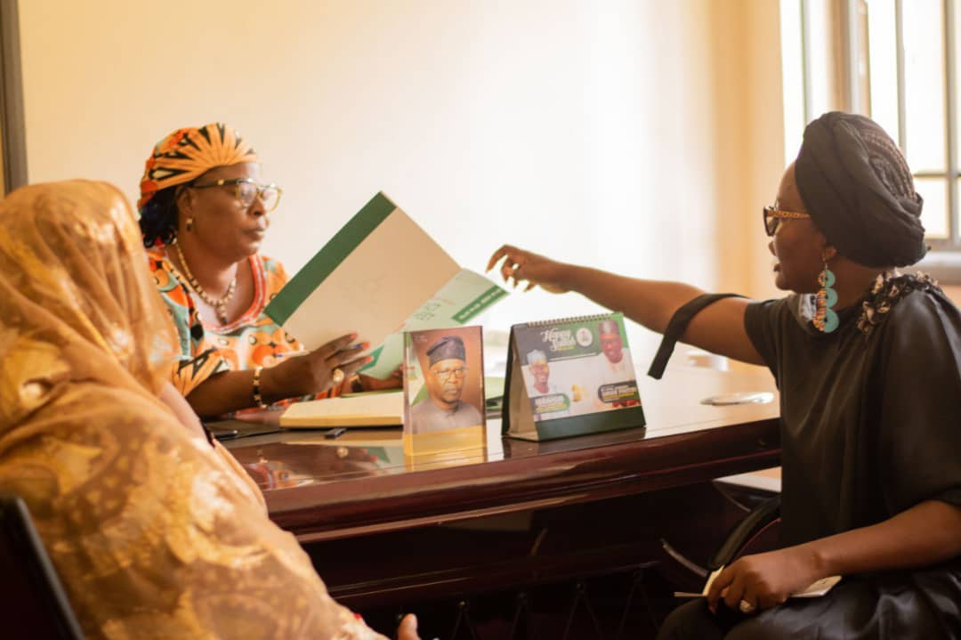
ADVOCACY VISIT TO THE PHC DIRECTOR
TFT conducted an advocacy visit to the PHC Director, Adamawa State to gain her support in welead project interventions with the goal of increasing access to SRH-R Information and services for young women and girls affected by displacement at the grassroot level. During the visit, a fact sheet containing the progress, challenges, interventions of the Welead project and our ASK was presented. The PHC director affirmed SRH as a salient issue and committed to support the organization in its project implementation via provision of SRH-Information at PHCs in communities. She added that the Adamawa State Primary Health Care Board with funding from UNICEF, is currently implementing a project to scale up ASRHR in the state. Intimating the team that health service providers in PHCs have reached AYPs through monthly meetings and sessions in 161,705 L.G.As. However, she made an appeal from the organization for training supports and IEC materials on SRH-R.
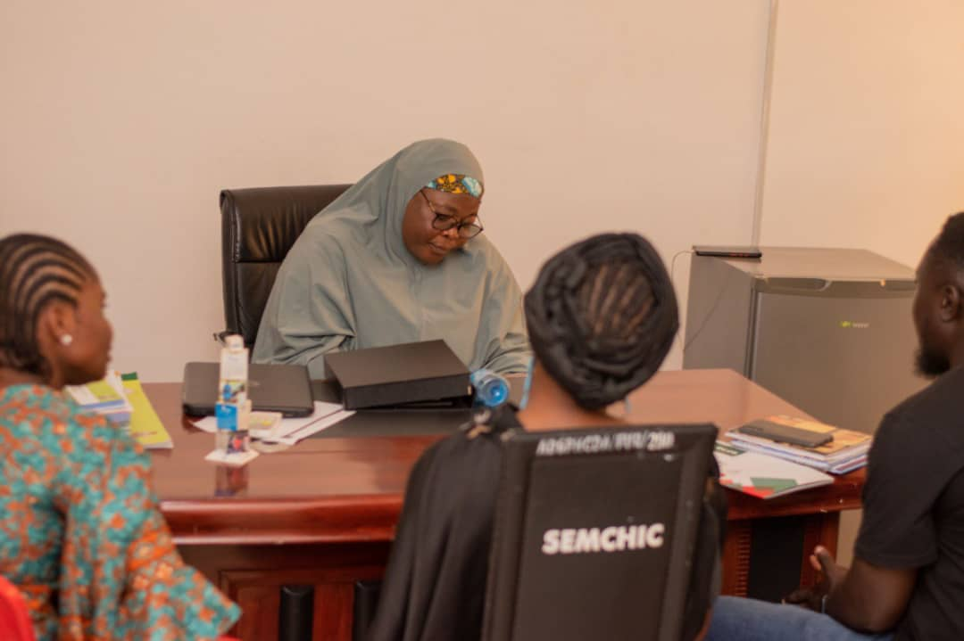
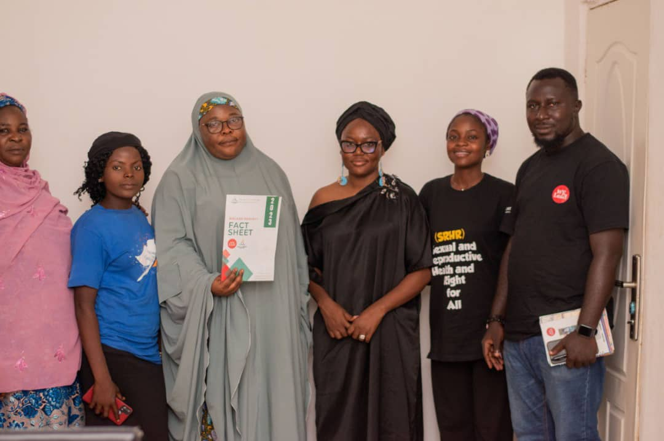
RIGHTHOLDERS CAPACITY ASSESSMENT
10 TFT right holders in Damare and Salama Housing IDP Camp respectively participated in an assessment exercise conducted by Education as a Vaccine (TFT implementing partner) which entailed an in-depth analysis of right holders’ on advocacy and communication skills on SRHR using a digital survey tool for collation of responses. Findings from the assessment revealed the SRHR needs and issues among right holder groups such as (insufficient information on SRH, issues of accessibility and affordability of SRH services and commodities) which necessitates a capacity building/training for right holders on SRH-Rights.

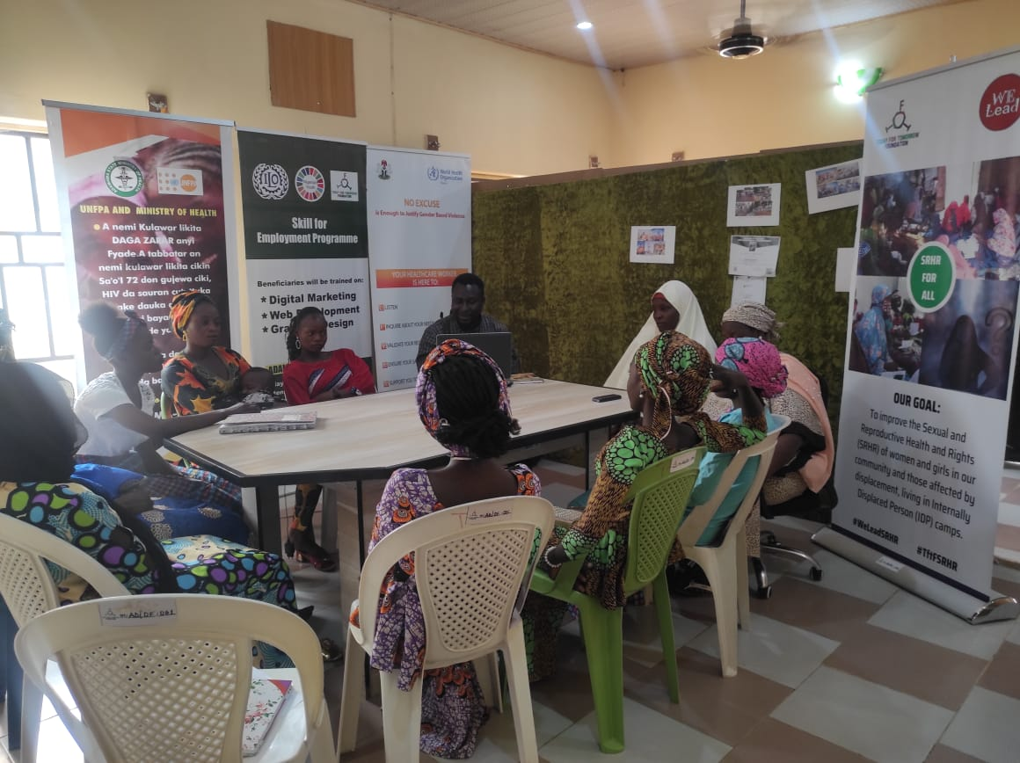

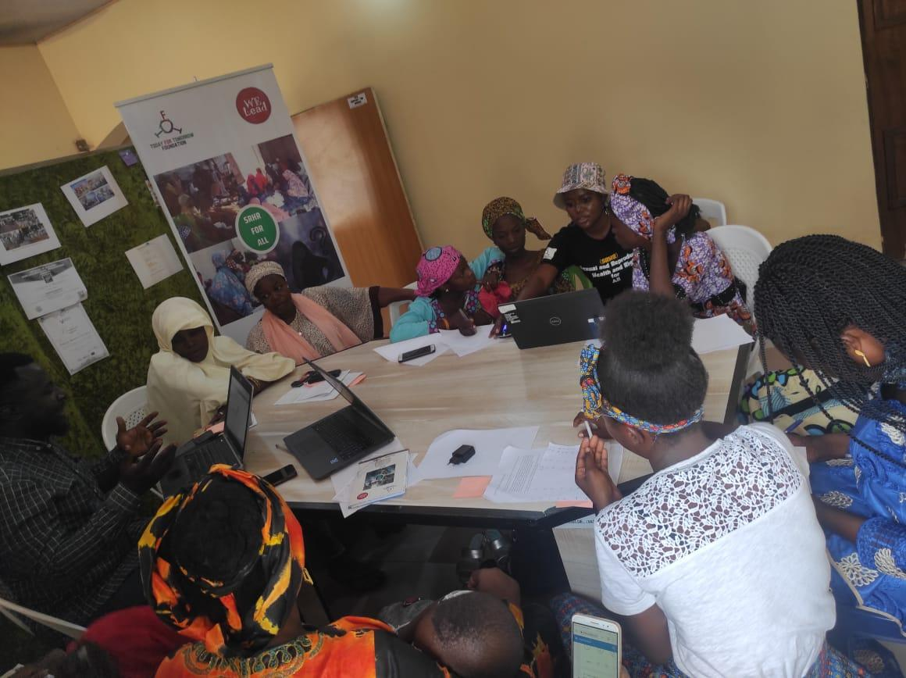

MEETING ON DEVELOPING SRHR ROADMAP
TFT organized a on-day meeting on developing SRHR Roadmap by 15 CSOs and 2 MDAs aimed at increasing SRHR programming among Youth led CSOs and NGOs in Adamawa State held on 12/6/2023. During the meeting, an overview of the Welead project on SRH-R implemented by the organization was discussed, emphasis was laid on the global SRH-R goals, SRHR issues and challenges faced by right holders in IDPs and the 4 outcomes of welead project were itemized and vividly discussed. Moreso, Youth-led organizations and line ministries present at the workshop were meaningfully engaged which led to the development of SRH-R Roadmap for the state.
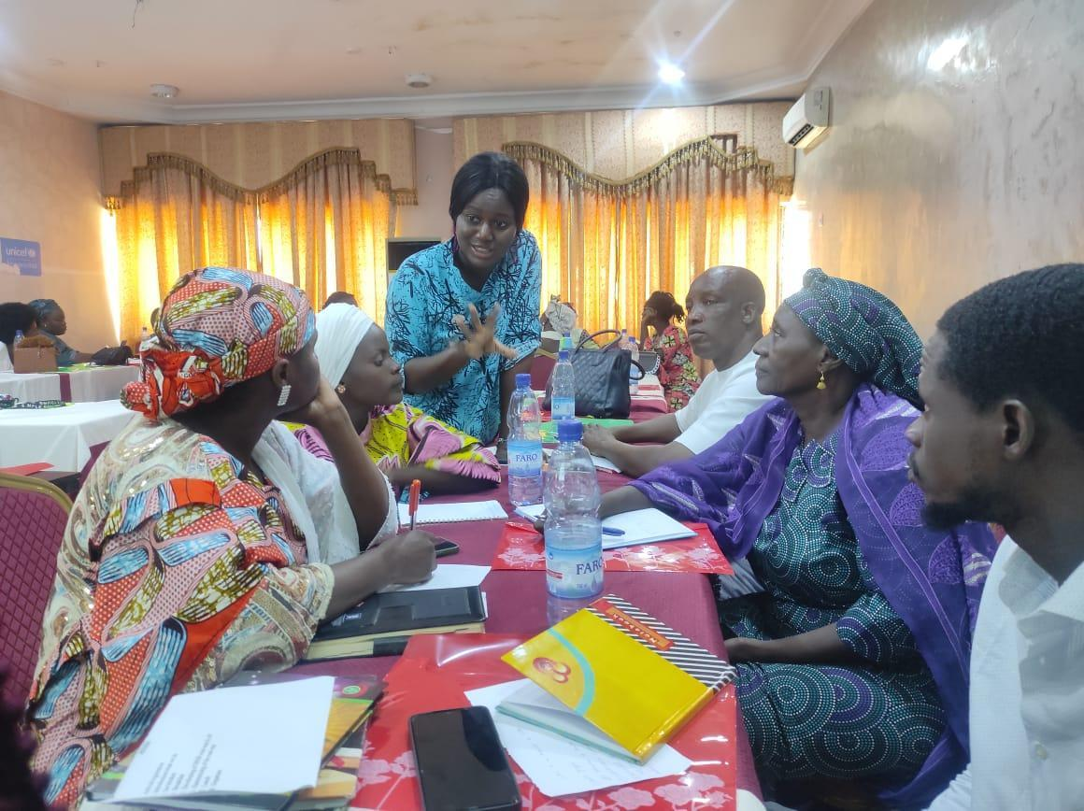
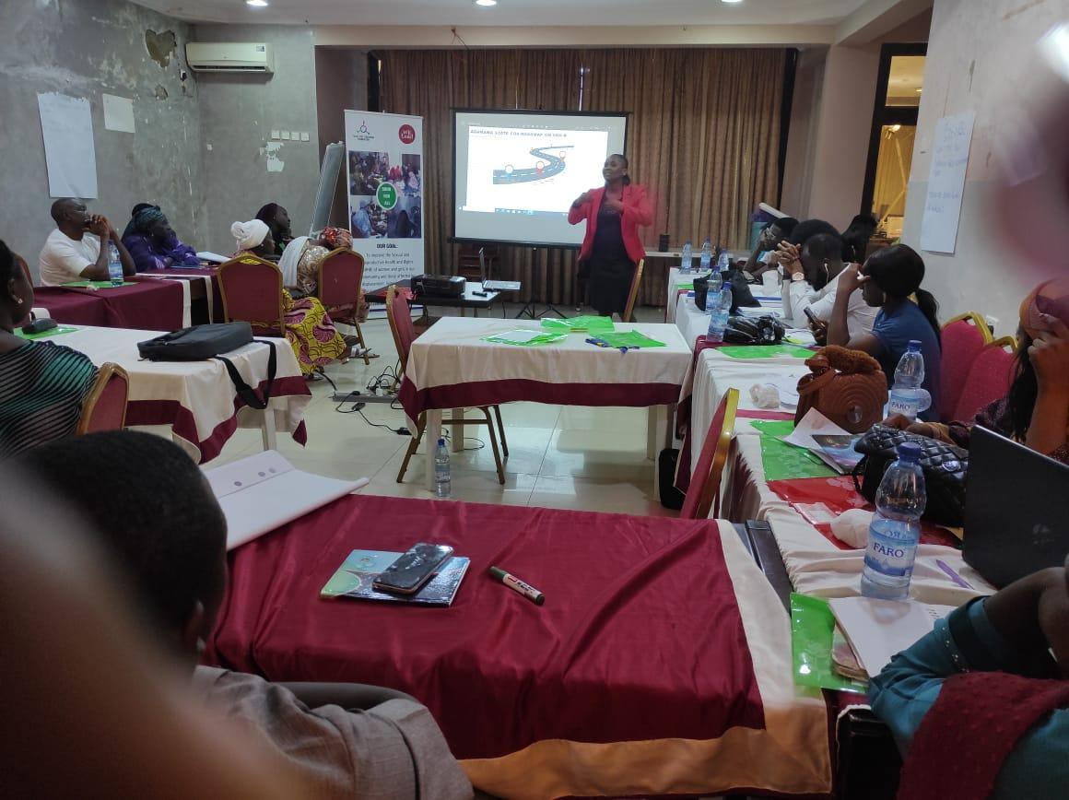
ADVOCACY TRAINING FOR CSO’s ON SEXUAL AND REPRODUCTIVE HEALTH AND RIGHT (SRH-R) IN ADAMAWA STATE
TFT organized a one day Advocacy training on Sexual and Reproductive Health and Right (SRH-R) Advocacy with a focus to increase knowledge on SMART advocacy which targeted a total of 25 CSO’s and 4 right holders within 15-35 years of age.
The training consisted of two (2) sessions; firstly, on SRH-R Advocacy and secondly on SMART Advocacy. During the sessions, primary goals of SRH-R, the different sexual rights, key aspects of SRH-R and benefits of SRH-R legislation and SMART Advocacy were extensively discussed. However, SRHR issues and Advocacy challenges were raised by right holders and Participants which includes; absence of safe space/Youth Friendly Centers, Discrimination/ Marginalization as well as prejudice. In furtherance, the facilitator led the participants to identify possible ways to mitigate the SRH-R and advocacy issues in the state which led to the development of CSOs call to action plan on SRH-R.

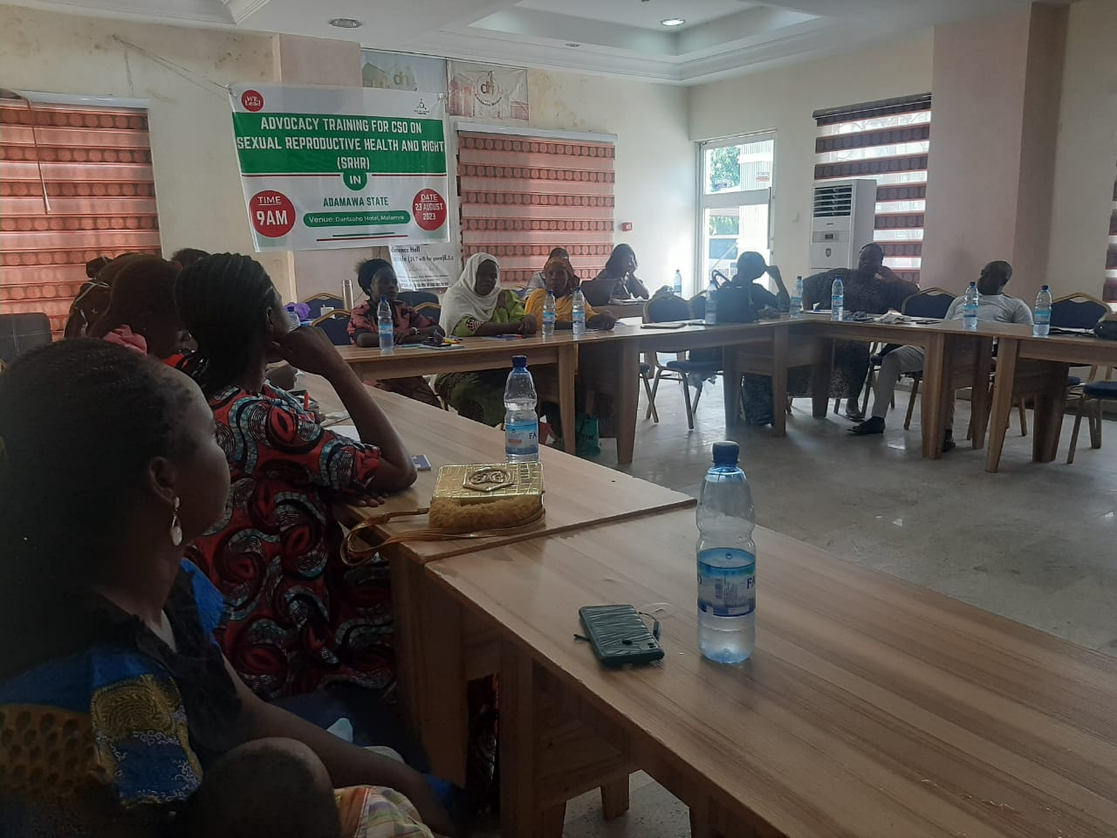

RADIO DRAMA PLAY

TFT developed and aired a radio drama play on Sexual and Reproductive Health, titled “NA OUR MATTER” on Fombina FM (101.5), Yola. The radio drama encompassed 8 episodes; each episode played for a duration of 30 minutes every Monday, Tuesday, Wednesday and Fridays at 5:30pm-6:00pm. The aim of the radio drama was to accelerate public consciousness on SRHR issues among women, girls and men and to cultivate positive behavioral communication change on SRHR particularly on existing societal and cultural norms and myths around SRHR.
During the airing of the radio drama play, contributions from callers were entertained and questions asked were responded to by team members positioned at the radio station.

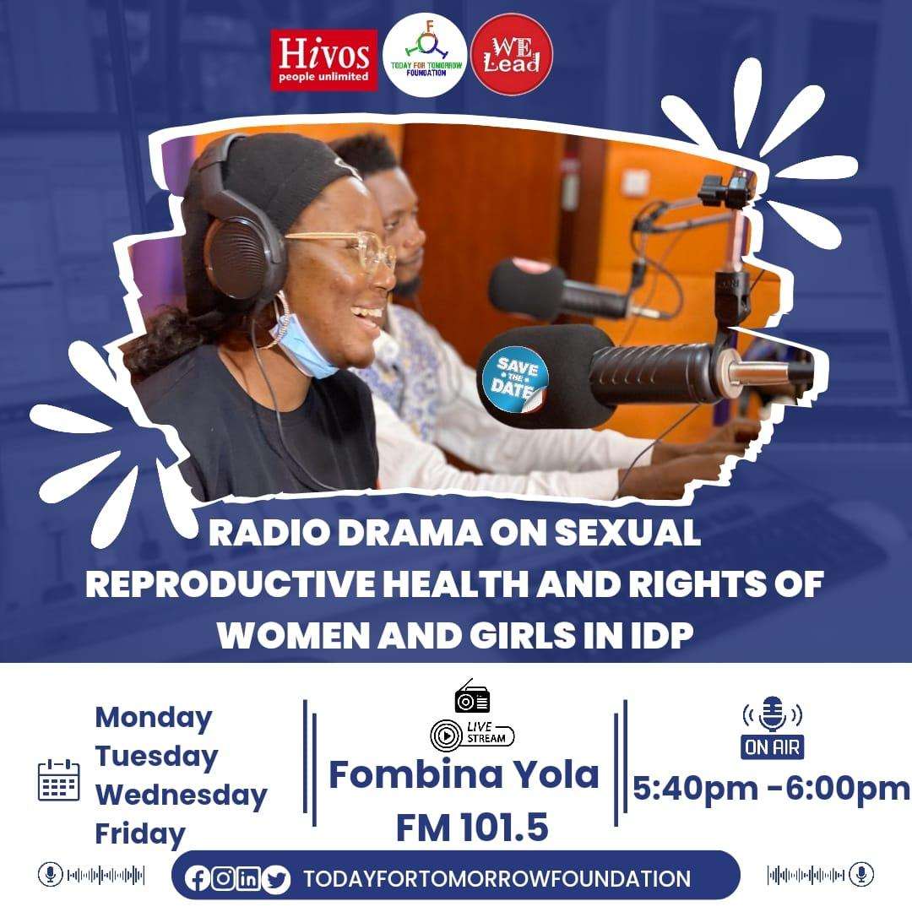
TRAINING OF RIGHT HOLDERS ON SRHR LAWS AND POLICIES
TFT conducted a training of right holders on SRHR laws and policies with 25 participants (young women and girls in Salama and Damare IDP camps respectively) in attendance including; 22 females and 3 males. The training was necessitated as a result of the knowledge gap identified during mid-term review of the project and aimed at increasing knowledge on available SRH-R laws and policies. The training was facilitated by the welead project officer with 3 duty bearers including; SRH coordinator, ministry of health, FIDA and Director of Primary Health Care. During the training, participants were admonished on the need to speak up in times of violence and to speak up on time after an incident in order to gain valid evidences geared towards punishing offenders and discouraging would be perpetrators.

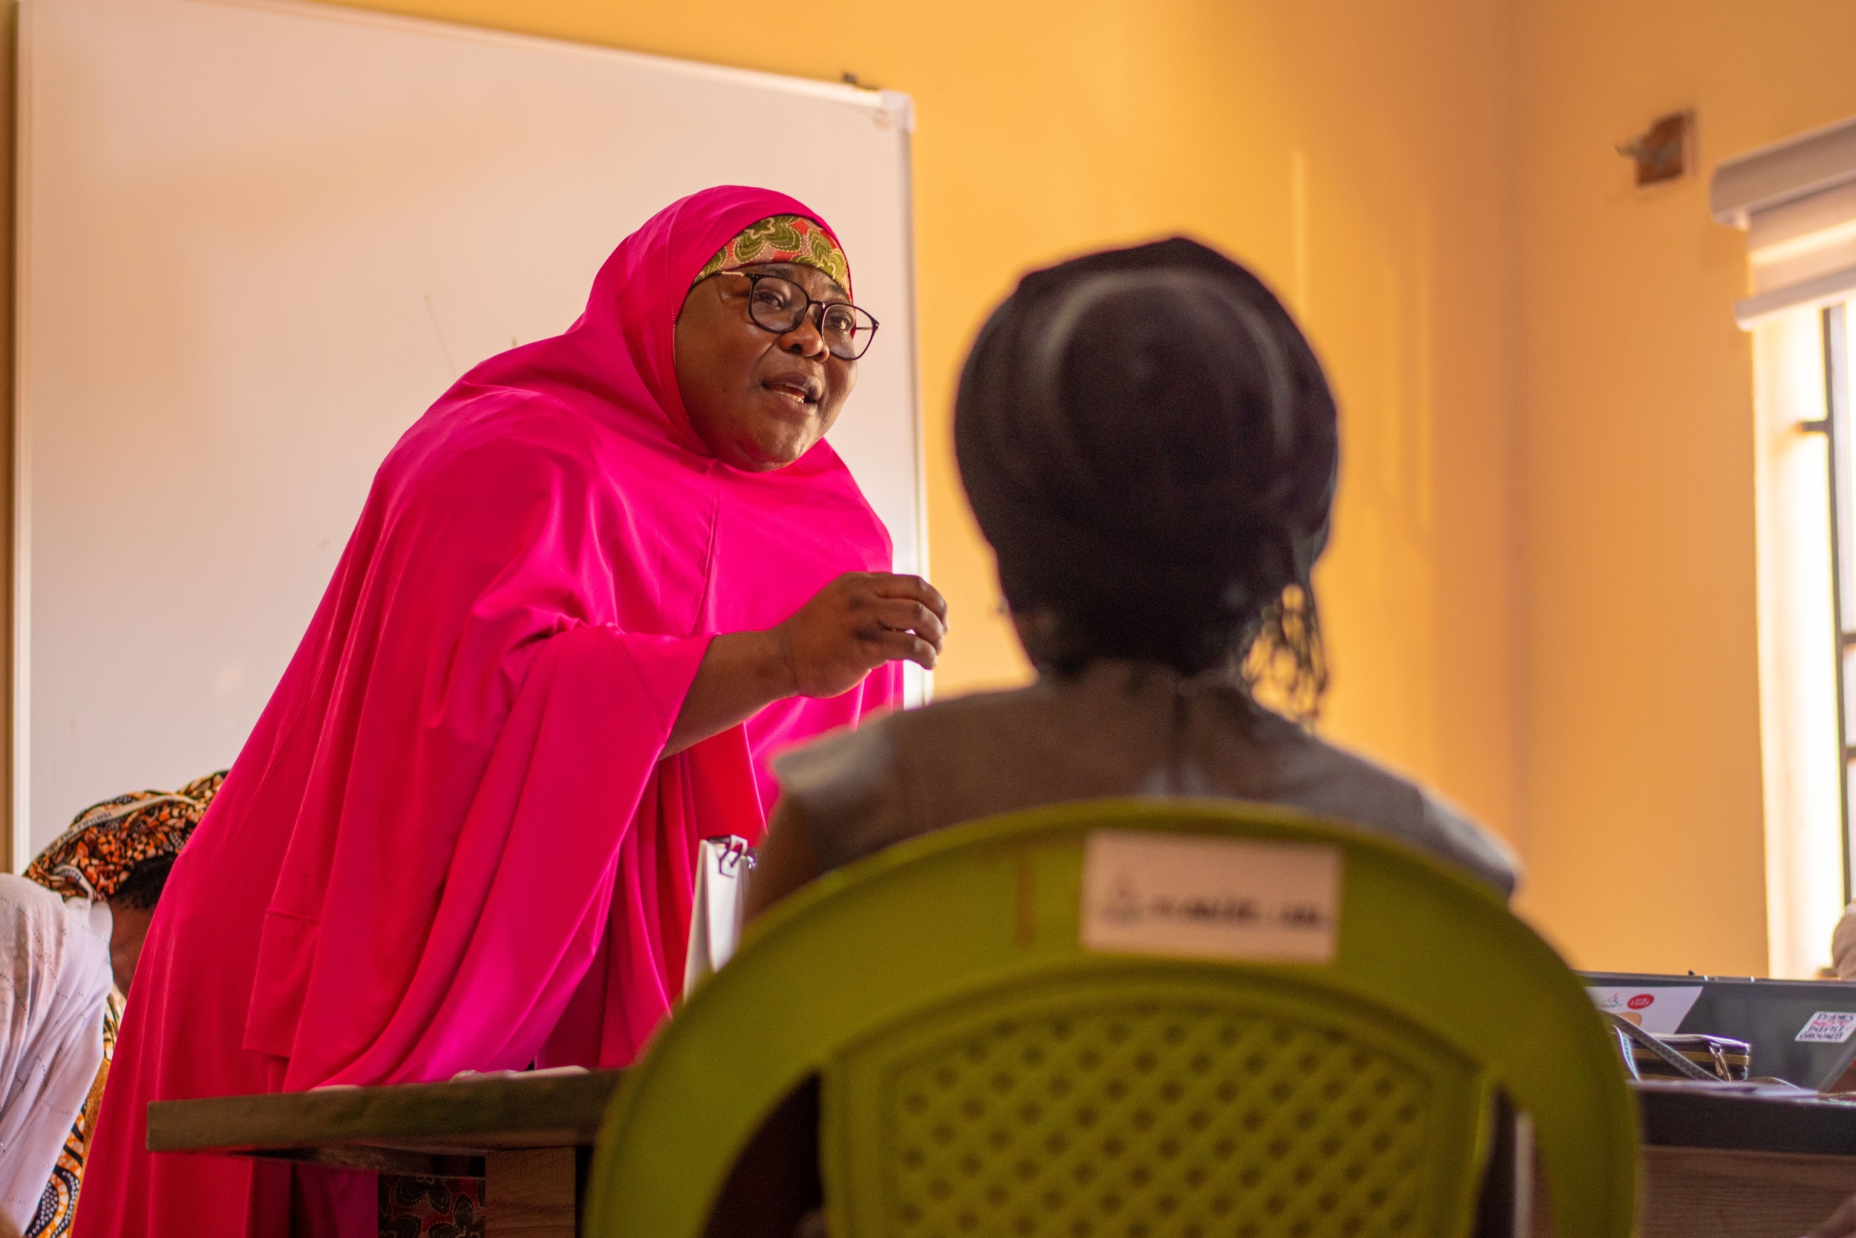
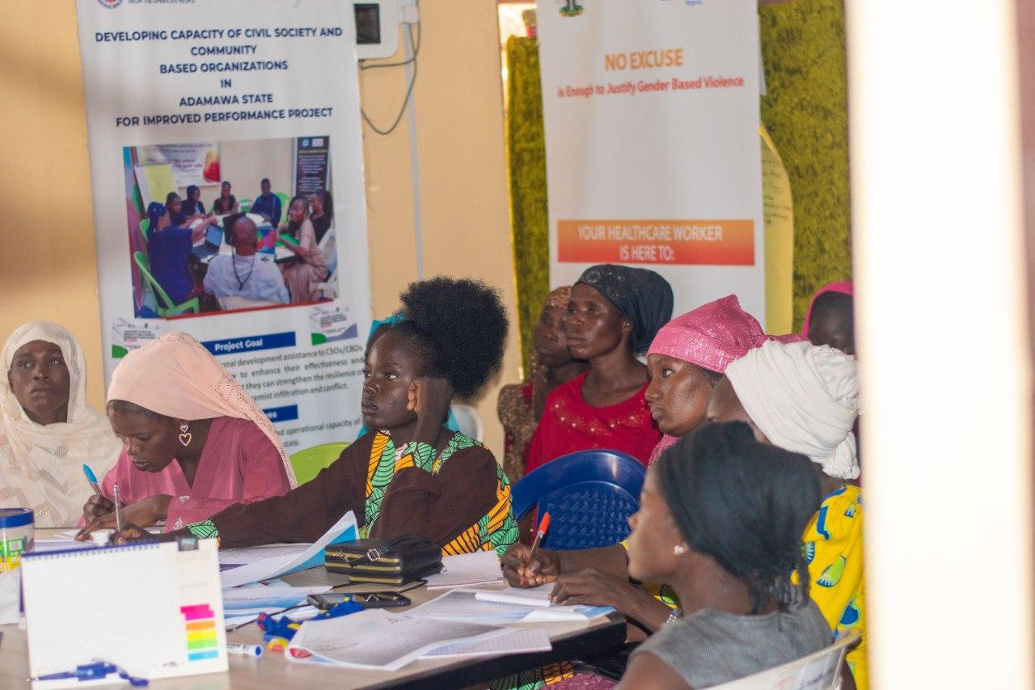

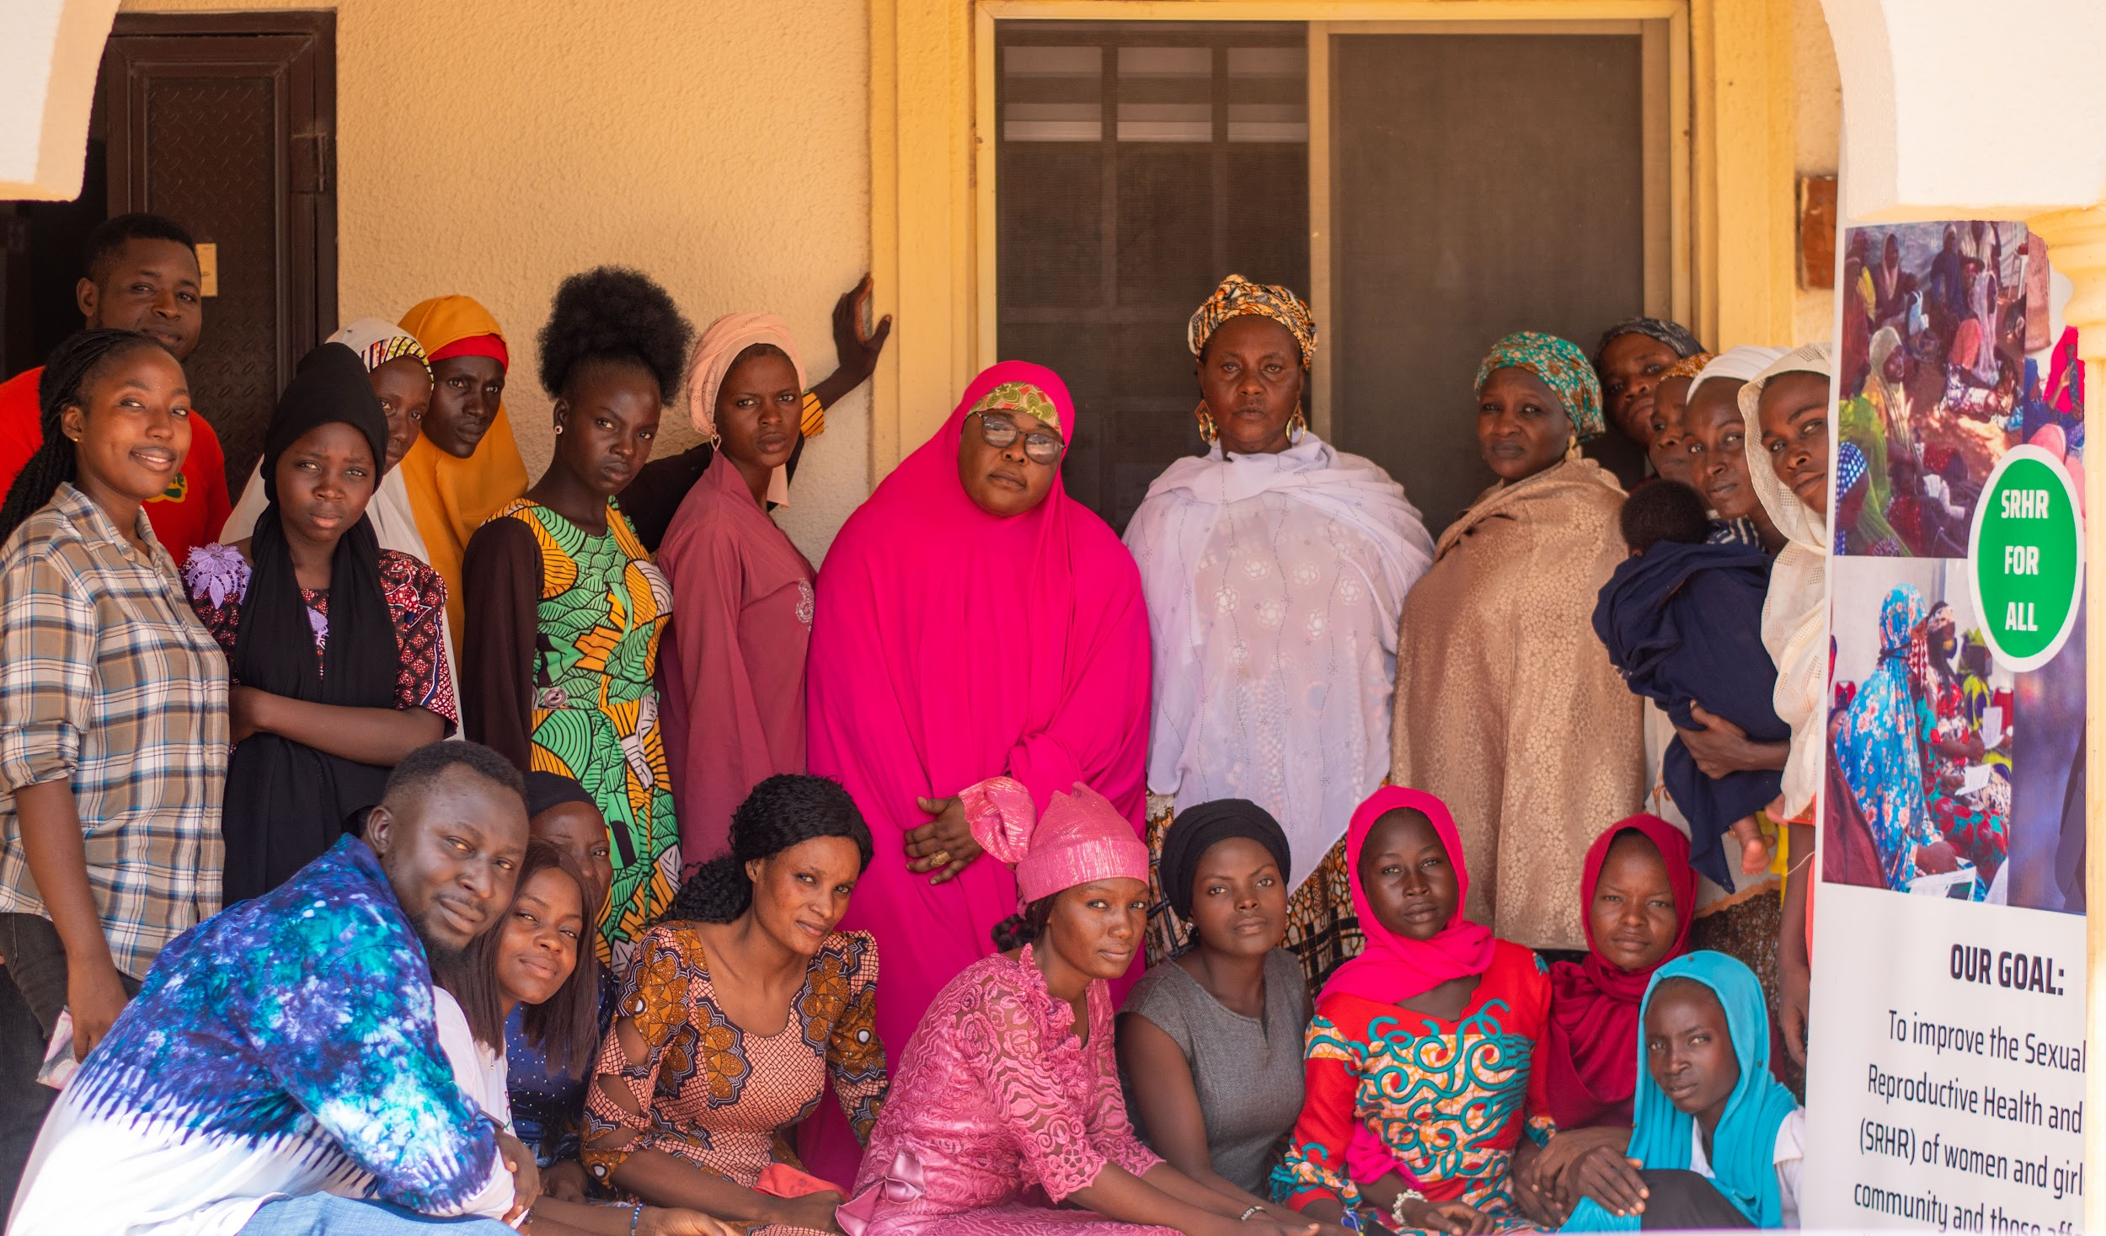
NEEDS ASSESSMENT OF SERVICE PROVIDERS
TFTF conducted needs assessment of service providers providing inclusive SRH services across 12 facilities in Yola North, Yola South and Girei LGAs with 20 participants in attendance. The aim of the assessment was to access service provider needs in providing accessible, quality, comprehensive, and inclusive youth-friendly SRHR services. During the needs assessment exercise, the director of Adamawa State Primary Healthcare Agency, 4 Programme managers from the board and coordinator-ASRHR were in attendance. Analysis of the needs assessment revealed that service providers in Primary Health Care centres are directly providing SRH services and information to young women and girls through sensitization on health education, menstrual education, maternal and child health care as well as family planning. However, across all facilities, findings revealed that there is inadequate SRH commodities, no standardized SOP or policy document on SRH, insufficient and unrevised manual on Comprehensive Sexuality Education (CSE) as well as unrevised IEC materials on SRH in PHCs. Also, the training health needs for services providers was analyzed using a pile ranking methodology with training of GBV as most prioritized and training of technical and facility staff on comprehensive sexuality education delivery respectively.

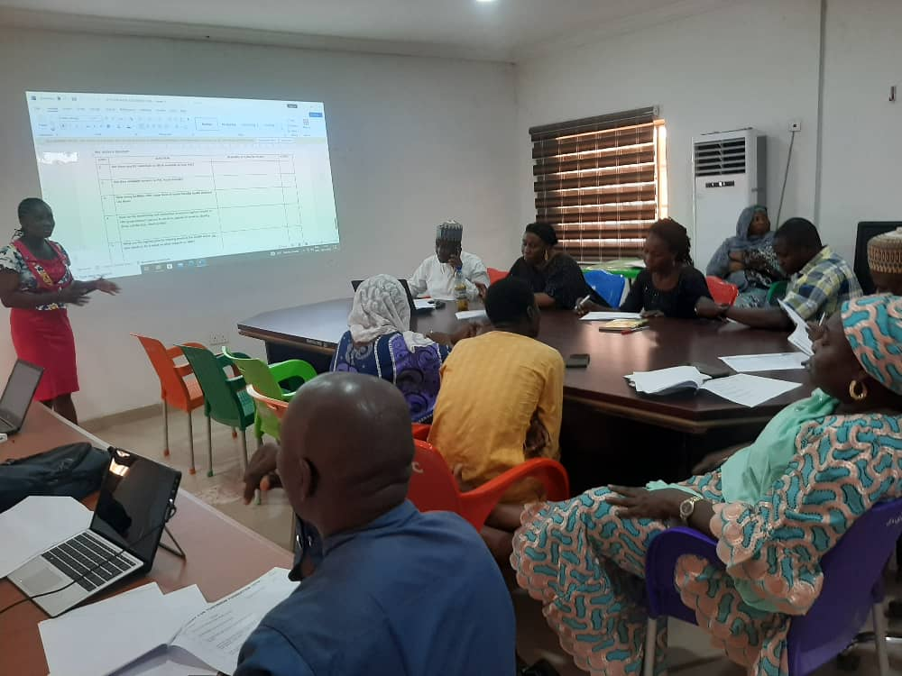

ACTION HEALTH INCORPORATED (AHI) PROJECT
AHI is a non-profit organization dedicated to promote young people’s health and development in Nigeria by increasing public awareness on health programmes and youth development. AHI was awarded by UNFPA with funding to scale up GBV and SRH-R programmes by sub-granting nascent organizations and Youth-led Civil Society Organizations (CSO) across the federation.
TFT is one of the CSO whose thematic area and proof of work across the years align with AHI and was sub-granted to implement GBV and SRH-R risk mitigation activities in Adamawa State.

COMMUNITY SENSITIZATION ON SRH-R AND GBV
Today For Tomorrow Foundation with funding from AHI conducted a 2 days community sensitization program on Sexual and Reproductive Health and Rights and Gender Based Violence for 600 participants (400 from Daware IDP Camp, Fufore L.G.A and 200 from Damare IDP camp, Girei L.G.A respectively).
The sensitization was aimed at increasing awareness on GBV and SRH-R among young women and girls affected by displacement. During the sensitization, the facilitators led the participants to extensively discuss the meaning of Gender Based Violence, it's types and it's effects and intimated the participants of the existence of the SRH-laws and policies; imploring them to acquaint themselves with the laws such as Violence Against Persons Prohibition (VAPP) Act which promotes their sexual and reproductive health and protects the rights of persons irrespective of gender and intersectionality.

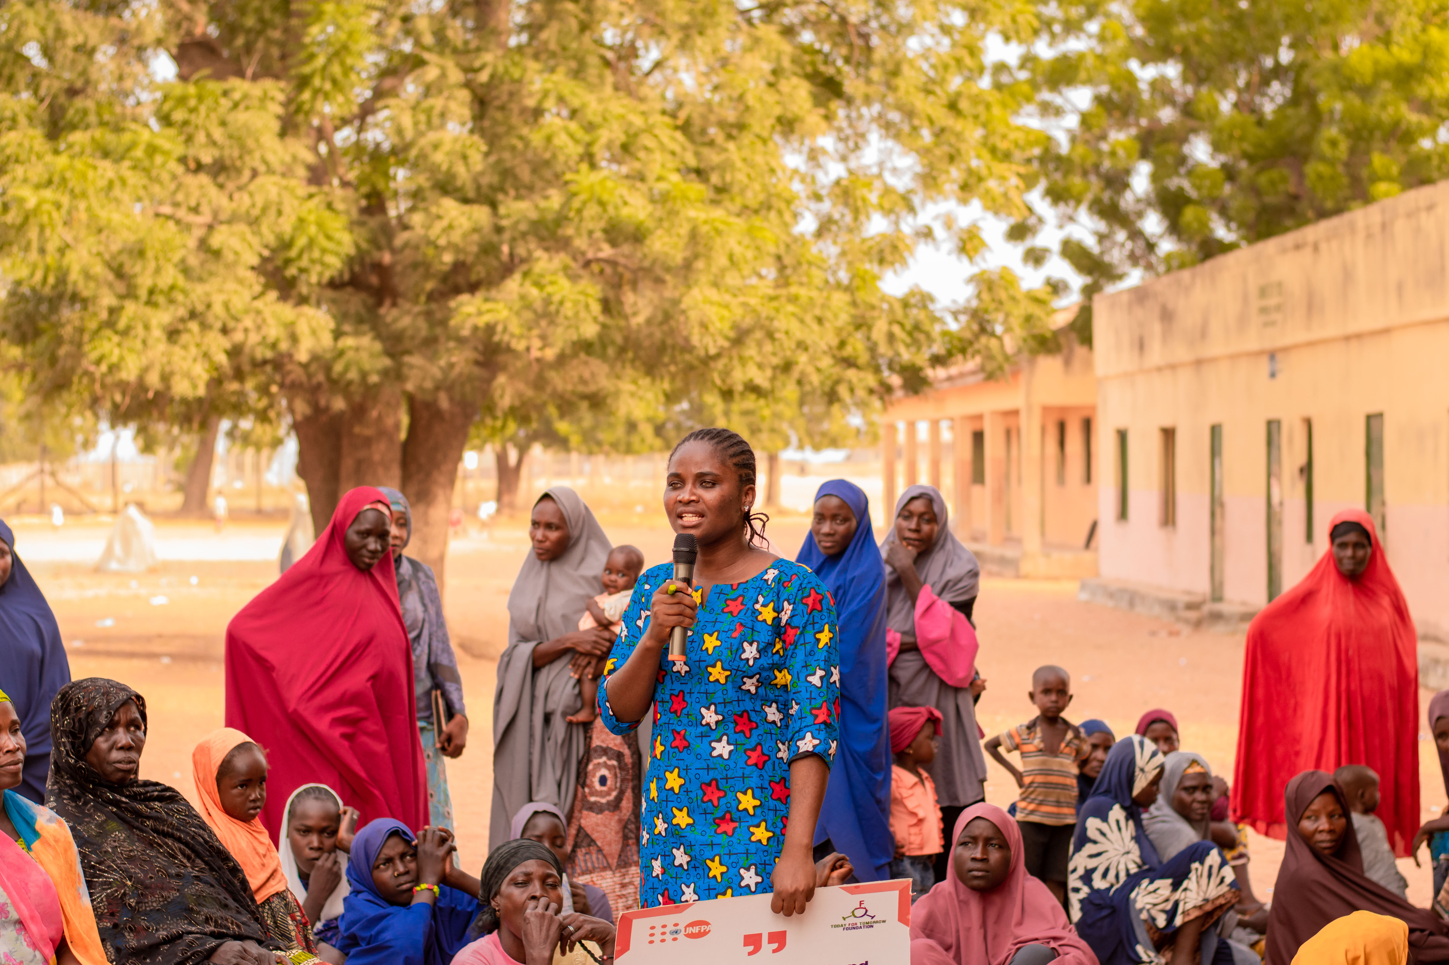

ANNEX(ES)
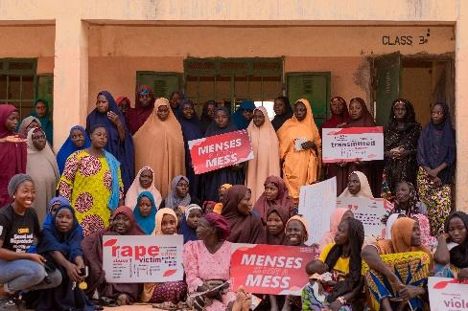

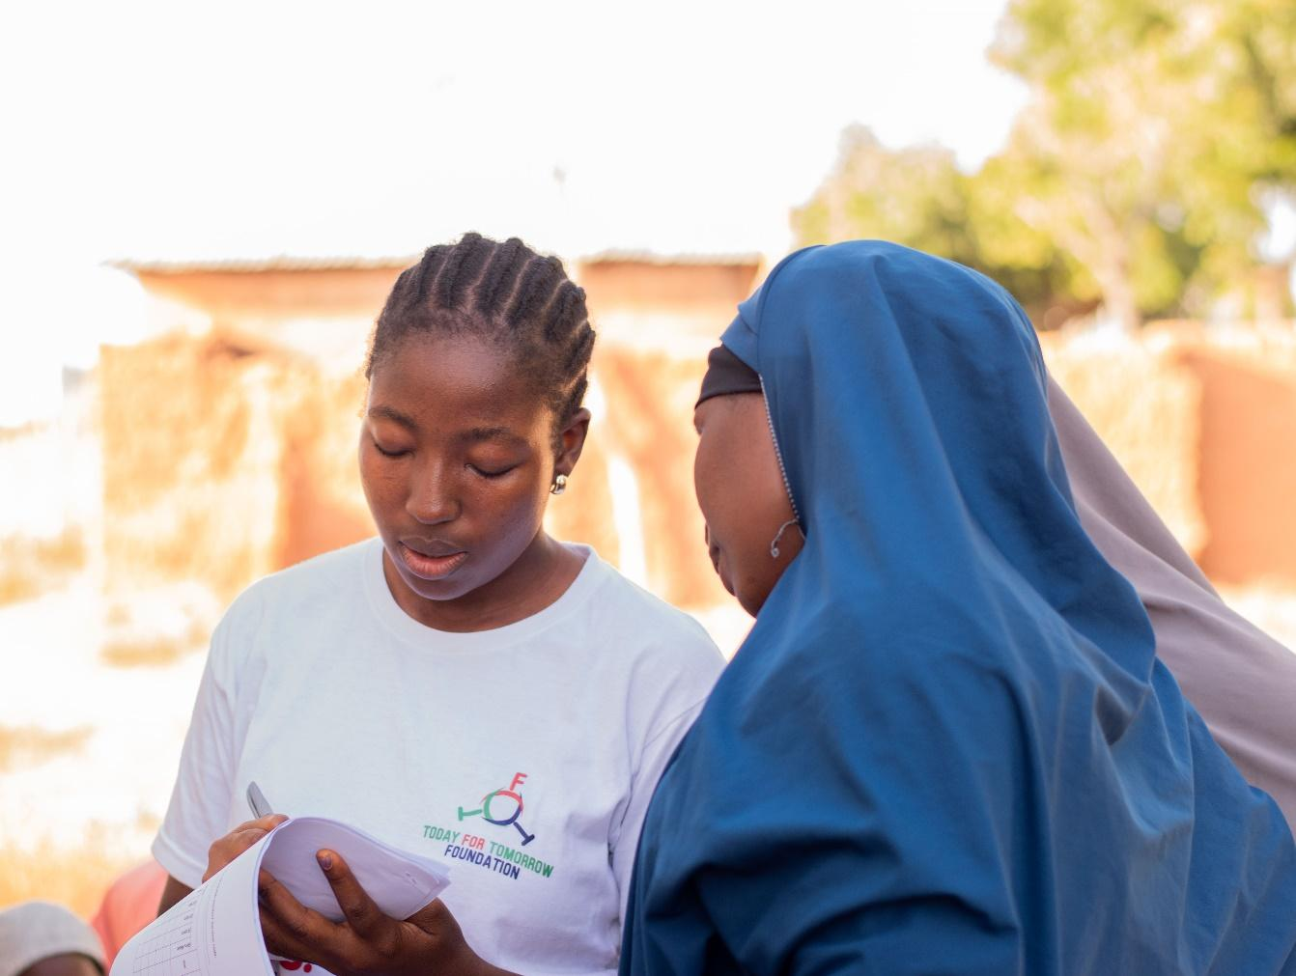

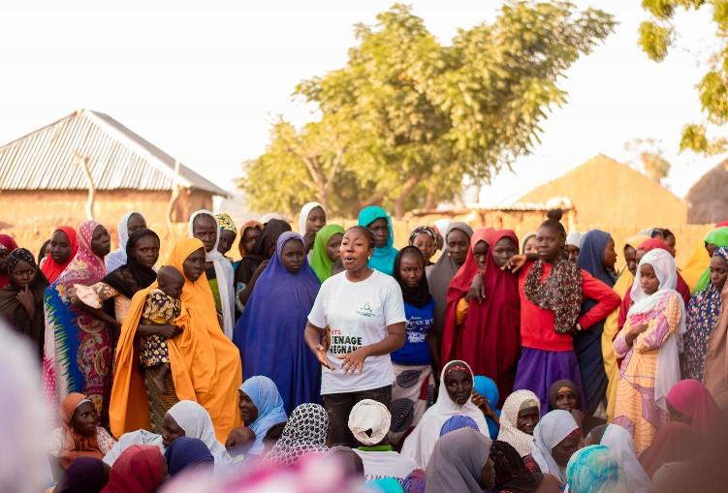
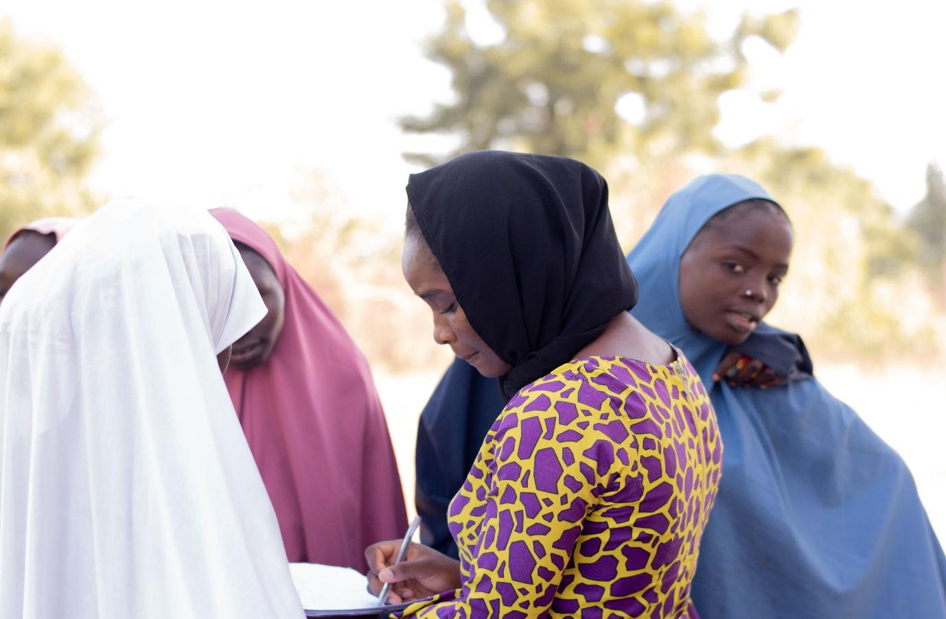
PARTNERS


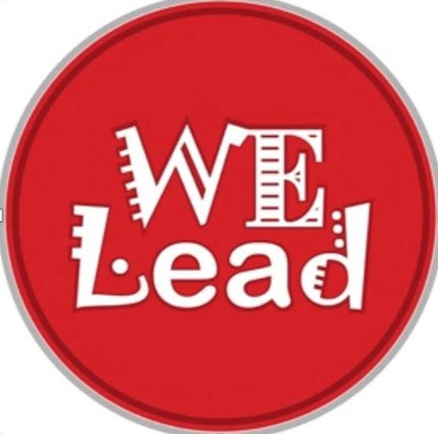
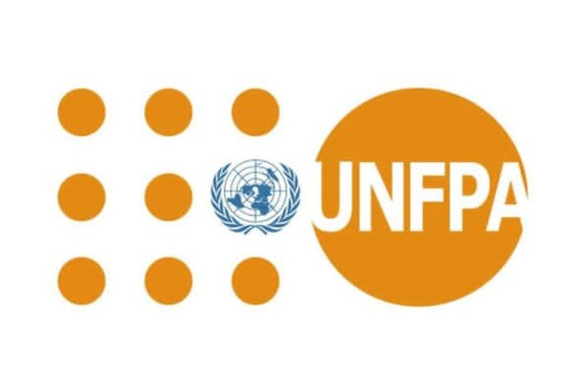
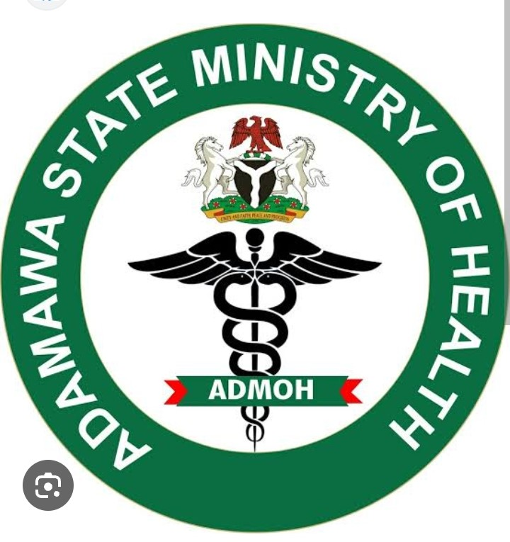
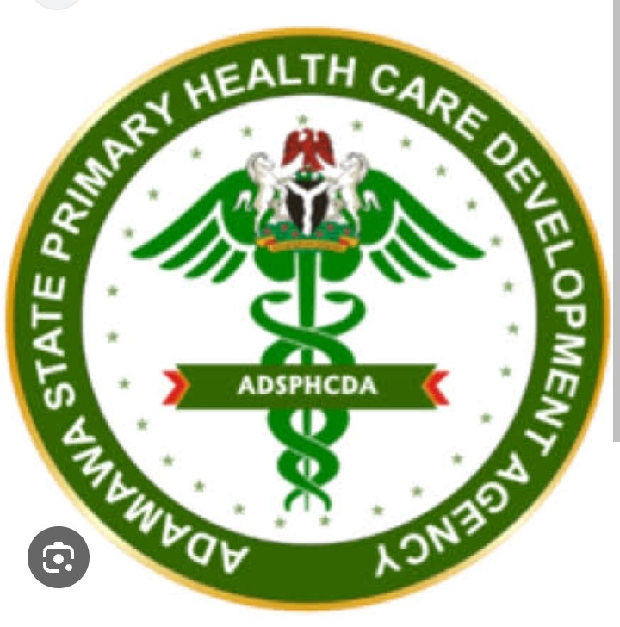

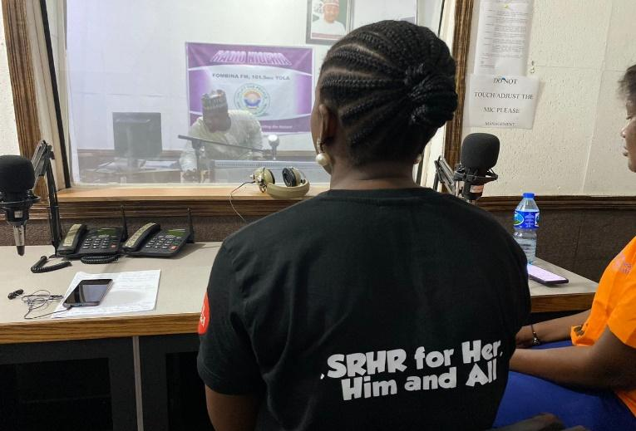




Todayfortomorrowfoundation today4tomorrowfoundation FoundationTft

Todayfortomorowfoundation

Kerawa massakare by Boys brigade, kimeta Yola.

Email: today4tomorrowfoundation@gmail.com or tftf@tftfoundation.org
Phone No: + 234 (0) 8167388820

