TODAY FOR TOMORROW INITIATIVE (TFT)

2024
ANNUAL REPORT

TABLE OF CONTENTS

- IMPACT
- PROGRAMS
- International Commemorative Days
- HIVOS – Welead (SRH-R) Project
- HDP Nexus Project
- Partners and Donors
- Contact Information
Who We Are
Today for Tomorrow Initiative (TFT) is a youth-led, a youth-serving non-governmental organization (NGO) working with young people for young people and saddled with the responsibility of developing and implementing solutions aimed at addressing health, social, developmental and economic problems that affect the complete well-being, attainment of rights, and full potential of 10–19 years old (adolescents), 20–29 years old (younger adults), and 30-35 years old within persons affected by displacement, persons living with HIV/AIDs, people with disabilities and adolescent and youth in the community.

Visit our website today, to learn more about us and our work
www.tftfoundation.org.ng

IMPACTS

TFT adopted a holistic and intersectional approach by ensuring that persons with disability and persons affected by displacement were meaningfully engaged in all program implementations for the year. Also, reporting tools and templates were re-designed to meet standard requirements capturing persons with other gender identities. Moreso, our organization integrated digital transformative tools and components to enhance Youths development, improve overall health (sexual and reproductive health) and well-being of our target beneficiaries and host community and increase campaign and awareness programmes on mental health and psychosocial support services.

INTERNATIONAL
COMMEMORATIVE
DAYS
Today For Tomorrow Initiative utilized international commemorative days such as: contraceptive day, mental health day, world menstrual health day and 16 days of activism to jointly advocate for increased support in meaningful youth engagement and youth development, establishment of youth friendly hub to enhance access to youth centered information and services and increased availability of SRH commodities and menstrual health kits at healthcare centres at the grassroot level.
- World menstrual health Day, 2024
TFT organized an informative campaign across 3 internally displaced persons (IDP) camp namely; Damare, Daware and Salama IDP camp, aimed at deconstructing notions and societal norms on menstruation with 72 participants in attendance. Focus group discussion methodology was employed during the activity to gain insight on similar and dissimilar perspectives on menstruation geared towards increasing positive behavioural change and practices among women and girls. Moreso, menstrual hygiene kits were evenly distributed to all participants.

Damare IDP

Ogoja IDP

Salama Housing IDP
- International Youth Day, 2024
Today for Tomorrow Initiative (TFT), alongside 16 other Civil Society Organizations (CSOs) focused on youth development, partnered with Adamawa State Ministry of Youth and Sports to host a conference commemorating International Youth Day. The event brought together transformative youth leaders with diverse and multidisciplinary understanding of youth development and digitalization to discuss issues affecting young people, highlighting the role of digitalization and technology in shaping a sustainable future. Moreso, youth leaders pinpointed the importance of youth inclusion, digital skills, entrepreneurship, and government support in creating opportunities and fostering resilience among the youth.

- Mental Health Day, 2024
In commemoration of 2024 mental health day, TFT conducted a one-day workshop on the theme "Time to Patronize Mental Health in the Workspace" with 7 participants in attendance including staff and volunteers. Key highlights during the workshop include clear communication, work-life balance, trust, collaboration, emotional safety, effective time management and the importance of physical comfort through ergonomic spaces.

- World Contraceptive Day, 2024
In commemoration of world contraceptive day, TFT conducted a sensitization campaign to increase public awareness on safe sex practices and use of modern contraceptives held at Bekaji Roundabout with 11 team members in attendance. The community members were sensitized on sexually transmitted infections (STIs) and its effects, modern contraception and use via a demonstration approach in order to make informed decisions about their sexual health. Moreso, flyers and health educational pamphlets which encompassed information about contraception, correct usage techniques of condoms were distributed to over 50 persons.

- 16 Days of Activism
During the 16 Days of Activism, TFT organized a media program (via 4 radio stations) to create public awareness on the concept of the 16 Days of activism, gender-based violence (GBV), root causes of GBV and report mechanisms on GBV to enhance effective case management and justice for survivors.

- Youth Walk Against GBV
TFT organized a youth walk against GBV and rape sponsored by UNFPA and voice of women empowerment foundation aimed at raising awareness about rape, advocate for justice for survivors and raised an action call for an end to gender-based violence with over 200 young persons in attendance. Key highlight during the walk was a call out and demand for survivor healing programs and strengthening judicial action against perpetrators.

HIVOS- WELEAD PROJECT ON SRHR
Welead is an innovative and far-reaching program that aims to strengthen the influence and position of young women whose SRH-R are neglected the most. TFT is one of the Community of action (COA) implementing the 4th phase of Welead project on Sexual and Reproductive Health and Rights (SRH-R) in the north-eastern part of Nigeria (Adamawa State). Moreso, our target group/beneficiaries are women and girls affected by displacement aged 15-45 years. However, our organization also ensure inclusivity of other vulnerable group including persons with disability.

- Conducting 2 days internal project implementation review and VCAT /self-esteem training with project team and RH

Today for Tomorrow Initiative held a two-day internal project review and Value Clarification and Attitude Transformation (VCAT) training for its 2024 implementation team, including 3 right holders and 12 staff. The training focused on reviewing the 2024 Welead work plan, designing the logical framework, and fostering positive attitudes toward Sexual and Reproductive Health and Rights (SRHR) for displaced persons.
Key highlights during the training include; reviewing welead project factsheet for 2023, identifying SRHR needs and gaps and planning 2024 interventions across four internally displaced persons (IDP) camps in Adamawa and Cross River States respectively.

- Advocacy Visit to National Human Right Commission (NHRC)
TFT conducted advocacy visit to Adamawa State National Human Rights Commission (NHRC) to strengthen collaboration with the commission in supporting and upholding the sexual and reproductive health and rights (SRH-R) of women and girls affected by displacement with 3 staff in attendance. During the visit, TFT Executive Director (Adek Bassey) appreciated NHRC's support in prioritizing SRH-R needs, domesticating relevant laws like the VAPP Act, highlighted the WeLead project impact in the state and the need to collaborate with the commission to identify and address human rights violations. The State Coordinator (Mrs. Grace Mamza) expressed commitment to supporting SRH-R advocacy and activities, reinforcing NHRC’s partnership with TFT to advance justice and prioritize reproductive rights for vulnerable groups in the state.

- Training of 12 Young Women and Girls as SRHR Drivers
TFT conducted a one-day training for 12 young girls as SRH-R drivers across 4 IDP camps in Adamawa and Cross River States aimed at enhance their knowledge and understanding on the concept of SRHR and equip them with skills to facilitate conversation around SRHR in the various camps. During the training, the participants were guided on technical report writing essentials to enhance their research skills.

- Menstrual health and hygiene awareness
TFT organized a one-day program on Menstrual Health and Hygiene Management in Bekaji secondary school for 30 girls within JSS1-JSS3 which was led by TFT project officer (Halima Daniel) and supported by other team members. The session aimed to improve menstrual hygiene practices, raise awareness, and support the girls with menstrual kits. The session was student centered as facilitation focused on menstruation, understanding your menstrual cycle, good hygiene practices and debunked myths. Participants actively participated during the sessions and the school administrator committed to collaborating with TFT to conduct periodic sessions for the students. Key highlight during the session was increased knowledge and behavioural change on menstruation.

- Step down training of 9 young data researcher for effective data collection
TFT held a one-day youth-led research training for 9 young researchers (aged 20-30) on Sexual and Reproductive Health and Rights (SRH-R) aimed at equipping young women and girls with essential research skills to effectively contribute to SRH-R initiatives. The training was facilitated by TFT Technical MEAL Officer (Marionet Kalu) and the sessions covered include; research frameworks, data collection methodologies, research techniques, ethics, safeguarding, informed consent and SRH-R components. Pre- and post-tests were used to assess participants’ knowledge before and after the training. Key outcomes included increased knowledge and capacity in youth-led research methodologies and improved understanding of effective data collection and survey practices.

- Conduct FGD session with leaders and men in Girei LGA to promote SRHR and support
TFT conducted a FGD session in Girie Local Government Area aimed at engaging men and community leaders in exploring their knowledge, attitudes and roles in supporting SRH-R of young women and girls affected by displacement with 25 men in attendance. Key findings during the session include:
- Limited SRHR Knowledge: Participants primarily associate SRHR with family planning and maternal health, often seeing it as a women’s issue.
- Barriers: Cultural norms and stigma hinder male involvement in SRHR.
- Men’s Roles: Advocacy, partner support, and challenging stigmatized norms were identified as ways men can contribute.
One day workshop on SRH-R and existing laws on SRH-R

Today for Tomorrow Initiative by conducted a one-day workshop with duty bearers to understand the position of duty bearers on the existing law and policies protecting the sexual reproductive health of young women and girls. Notably, there were existing gaps in awareness of SRH laws and policies among the right holders. During the workshop, legal frameworks, emphasizing on the VAPP Act, Criminal Code, and Child Rights Code were explored with actionable steps for sensitization and advocacy. Duty bearers pledged support and commitment to see that all existing law protecting the SRH of young women and girls would be domesticated.

- One day training of health service providers on youth-friendly SRHR service delivery
TFT conducted a one-day training for health service providers on youth-friendly SRH-R service delivery aimed at enhancing qualitative, respectful and inclusive SRH information and services for young women and girls affected by displacement with 30 health service providers in attendance. Areas covered during the training include; identifying and addressing SRH issues, technical competence needed in delivering youth friendly SRH-R service, characteristics of youth friendly SRHR service delivery, barriers (physical, institutional, psychological and individual) to youth friendly SRHR service delivery and strategies to enhance effective youth-friendly health service delivery. Moreso, it was highlighted that health service providers need to improve their technical skills to enhance confidentiality, inclusive and non-judgemental approaches in health service delivery.

SRH-R Drivers Programme
TFT designed the SRH-R drivers programme for a period of 7 months (April, 2024-October, 2024) with the aim of increasing access to SRH-R information and services among right holders (women and girls) affected by displacement and meaningfully engage right holders in leading SRH sessions. To achieve this, our organization engaged and trained 9 young women and girls to become SRH-R drivers in four (4) different IDP camps namely; Daware, Damare, Salama Housing and Ogoja IDP camp respectively to drive open conversations on SRH-R at the community level and increase public consciousness on SRH-R. Focus Group Discussion (FGD) methodology was used during weekly sessions to build great rapport with the right holders which enabled them to share similar and dissimilar views on knowledge of SRH and practices.
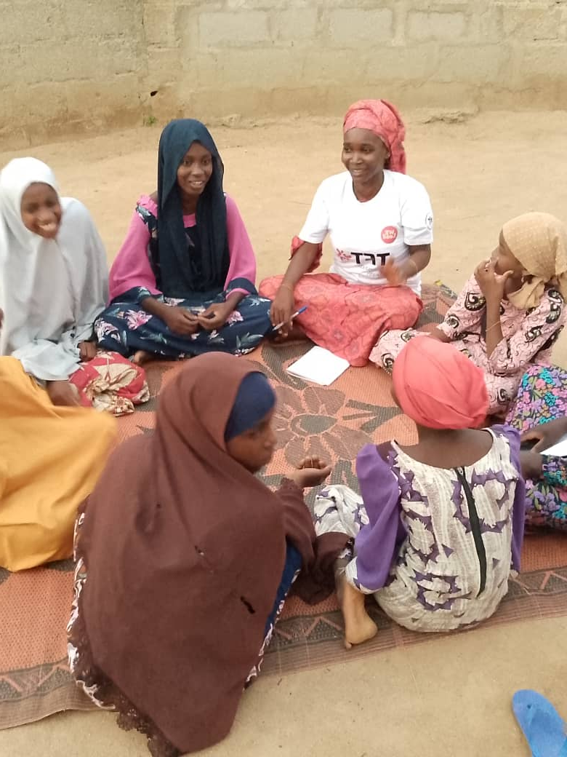
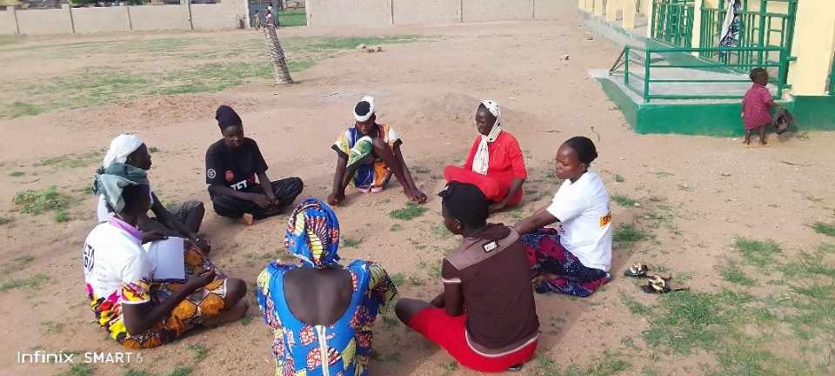

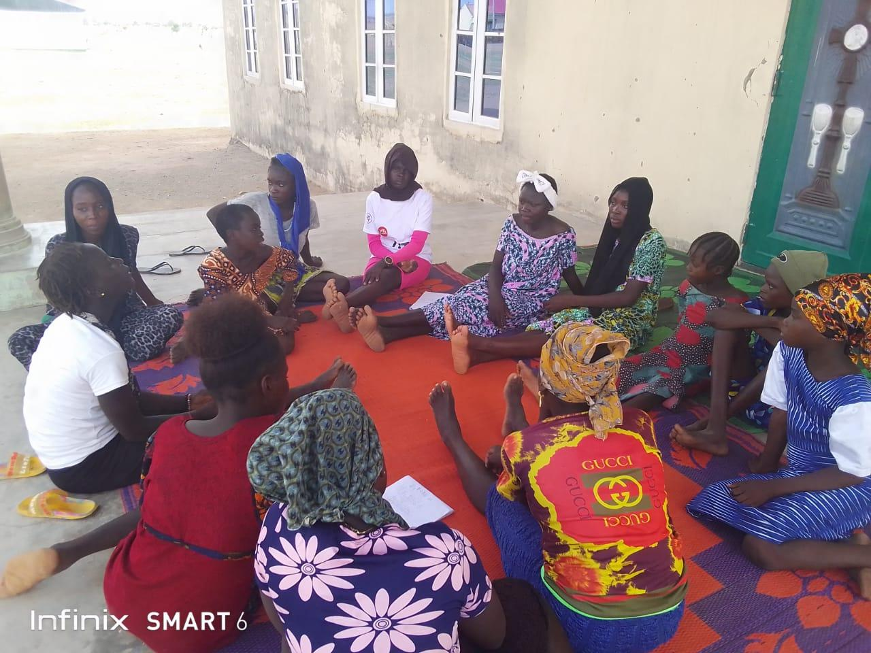

HDP NEXUS PROJECT
Aims to bridge humanitarian, development and peace building efforts to create sustainable solutions for vulnerable communities. It focuses on fostering interconnectedness among actors, achieving collective outcomes and addressing the root causes of crises.

Youth-led HDP Nexus training for communities in North-East, Nigeria
Today for Tomorrow initiative with funding from action aid Nigeria conducted a youth led community-based HDP Nexus training for 5 communities in Girei and Yola South local government area respectively in Adamawa state, namely; Salama IDP camp, Damare IDP camp, Damare host community, Malkohi community and Yolde Pate. The training aimed at equipping 150 community members with the knowledge of the HDP Nexus, strengthen capacity of community actors to map, analyze and address issues affecting their communities and equip participants with skills required to implement advocacy actions through the Nexus approach.

RE-SKILLING REVOLUTION AFRICA PROJECT
The Re-skill revolution Africa project is an initiative designed to empower graduates, undergraduates and post graduates with practical skills and innovative knowledge tailored to their needs and aspirations.

Digital Skills Training for Youths
Today for Tomorrow Initiative in partnership with IBM implemented an initiative to address the global skills gap, particularly in Africa, by empowering individuals and organizations with digital skills needed for the future of work. This initiative aligns with IBM and TFT vision of advancing education and fostering sustainable economic growth enabling young people to maximize their full potentials. The program emphasizes equipping individuals with in-demand skills in areas such as cloud computing, artificial intelligence (AI), data analytics, cybersecurity, digital marketing and information and technology foundation. In the space of one-month TFT were able to mobilize and enrol 475 participants.

PARTNERS


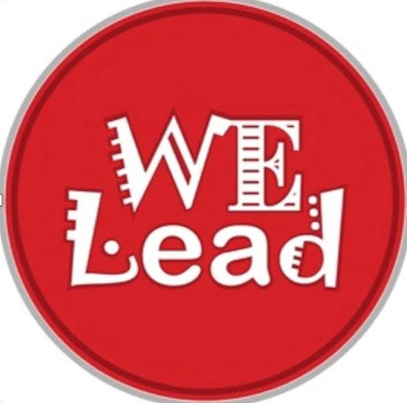
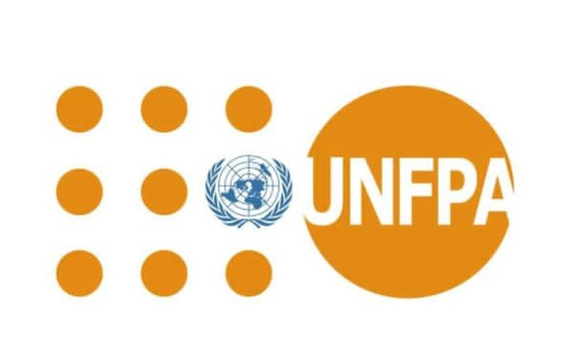
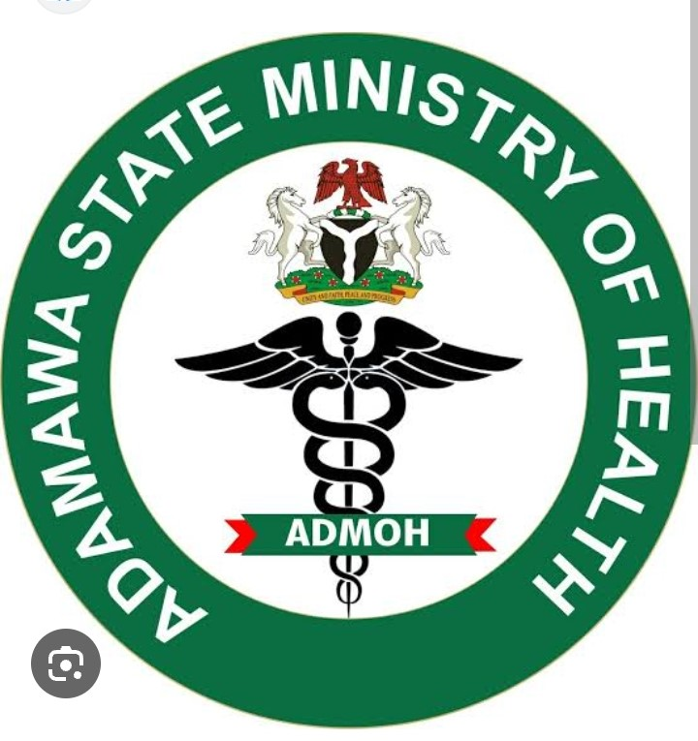
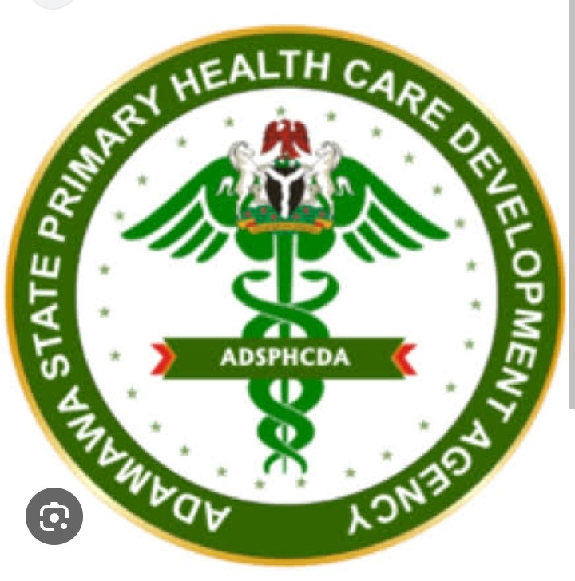

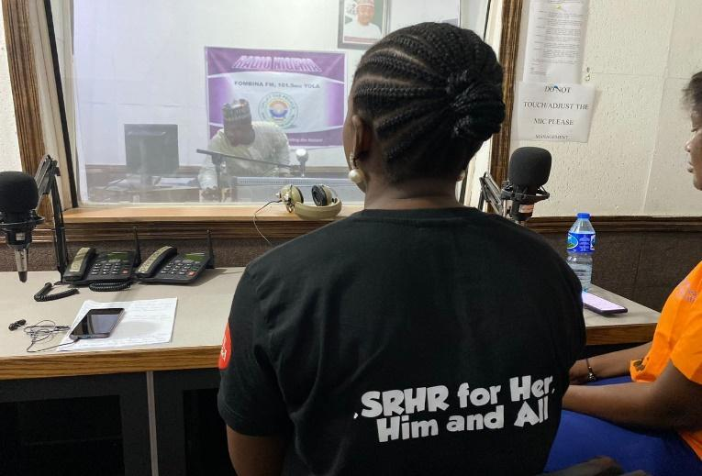




Todayfortomorrowfoundation today4tomorrowfoundation FoundationTft

Todayfortomorowfoundation

Kerawa massakare by Boys brigade, kimeta Yola.

Email: today4tomorrowfoundation@gmail.com or tftf@tftfoundation.org
Phone No: + 234 (0) 8167388820

